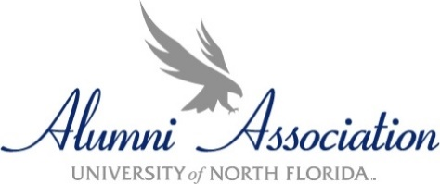
Please complete and return this form by 6/20/25 at 5 p.m. Combine the information requested below and electronically submit ONE PDF (including this form and all supplemental material) to the attention of the UNF Alumni Office unf-alumni@unf.edu.

Nominee’s Name ________________________________________ N Number_________________________________

Local Address________________________________________________________________________________

Preferred Phone __________________________Preferred Email Address _______________________________

College_____________________________ Major_______________________ Minor ______________________

How long has the nominee been enrolled at UNF? _________________________________________________________

Is the nominee planning to participate in your Commencement ceremony? _______________

In addition to this application, please attach the following information for the Committee's review.

- A no more than two-page autobiographical cover letter highlighting collegiate service endeavors including how volunteer service has benefited UNF and/or the community.

- Current professional resume.

- Two letters of recommendation outlining accomplishments and/or commitment to volunteerism.

- List of on- and off-campus organizations to which the nominee has belonged during their college career at UNF, length of time in each, offices held, and volunteer projects in which they have been involved. Please indicate if volunteer service fulfilled an academic requirement.

Please have the following information verified by a representative from the Registrar’s Office (this may take several days).

I certify that the person nominated on this form has applied for graduation for SUMMER 2025.

I certify that this person has a ___________ grade point average (min. 2.75 required.)

________________ __________________________________________________________________
Date Signature of Registrar’s Office Representative

