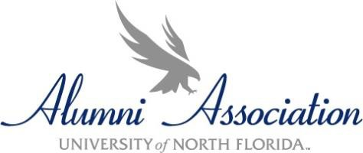

UNF Alumni Association Club Grant Application
for Registered Student Organizations SPRING 2025

The UNF Alumni Association is proud to offer grant funding for student clubs searching for sponsors to fund a specific project, trip or cause. Club Grant applications and all supporting information must be submitted electronically, in ONE PDF, to the Alumni Office, unf-alumni@unf.edu by 3/7/25 at 5:00pm . Questions may be directed to the Office of Alumni Engagement by emailing unf-alumni@unf.edu.

Club Information:
Club Name: Click or tap here to enter text.

Club President's Name*: Click or tap here to enter text. Phone:Click or tap here to enter text. Email: Click or tap here to enter text.
Advisor Name: Click or tap here to enter text. Phone:Click or tap here to enter text. Email: Click or tap here to enter text.

*Communications will be sent to individual submitting the application.

Funding Information:
Project/Event Name: Click or tap here to enter text.

Location of Project/Event: Click or tap here to enter text.

Date and Time of Project/Event: Click or tap here to enter text.

Purpose of Project/Event: Click or tap here to enter text.

Total Amount Requested: $Click or tap here to enter text. (maximum of $1,000)

By submitting this application, the club officers and/or advisor assumes responsibility for this expenditure. Club advisor affirms that all funding provided by the UNF Alumni Association will be used as presented unless a written amendment request is made and approved by the UNF Alumni Association. Funds shall be used within six months of award date; unused funds shall be returned to the Office of Alumni Engagement and Annual Giving on behalf of the Alumni Association. If funding is approved, it may take up to two weeks to receive funding.

Application packets should include the following:

Brief, typed report that includes the following information:
- Is the applicant a recognized club in good standing with Club Alliance? If not, you may send an appeal in writing to the Office of Alumni Engagement and Annual Giving, contact info below.
- How will UNF students be impacted by this grant request? What is an estimated number of UNF students both within and outside of this club that will be impacted?
- What other sources of funding and/or fundraising activities have been sought for this purpose?
- Has the UNF Alumni Association provided funding for this purpose before? If so, what was the outcome?
- What will happen if the UNF Alumni Association does not, or only partially funds this request? Line-item spreadsheet documenting expenses and wages for the project/event
Schedule/agenda/program/flyer/conference registration page/etc. and other supporting documentation for the project/event
Signed letter of recommendation on letterhead from club's advisor

Any student with a disability who requires reasonable accommodations to participate in any program or activity funded by UNF Alumni Association must first be registered with the UNF Disability Resource Center. Written requests for reasonable accommodations should be sent to the Director of the UNF Disability Resource Center.

REV: 5/4/2018

