NOTICE OF NEW REGULATION

June 9, 2023

FLORIDA BOARD OF GOVERNORS
Division of Universities
University of North Florida

REGULATION TITLE:
Linking Industry to Nursing Education (LINE) Fund

REGULATION NO.:
2.1110R

SUMMARY:
The new regulation is being proposed in accordance with BOG regulation 8.008, Nursing Education to create an opportunity for UNF to receive matching funds (LINE Fund), through a healthcare partner. The proposed regulation sets forth requirements of LINE funding proposals to be submitted to the BOG Chancellor’s office, requires UNF to notify the BOG upon receipt of funds provided by healthcare partner in the approved proposal before receiving matching funds, has an annual reporting component, if awarded LINE funds the previous fiscal year and authorizes the UNF Provost’s office authority to establish further policies for LINE fund administration in accordance with applicable legal and regulatory authorities.

MEETING DATE AND TIME:
July 10, 2023 @ 12:00 pm (virtual)

FULL TEXT:
The full text of the regulation being proposed is attached.

AUTHORITY:
Florida Constitution, Article IX, Section 7(c)
Florida Statute 1009.8962
BOG Regulation 8.008

UNIVERSITY OFFICIAL INITIATING THE PROPOSED REGULATION:
John Kantner, PhD, RPA
Senior Associate Provost of Faculty & Research

INDIVIDUAL TO BE CONTACTED REGARDING THE PROPOSED REGULATION:
Robyn Blank, JD, CCEP, Associate Vice President, Chief Compliance Officer, r.blank@unf.edu, 1 UNF Drive, Building 53, Suite 2341, Jacksonville, FL32224 (904)620-2258.

Any comments regarding the new of the regulation must be sent in writing to the contact person on or before June 23, 2023, to receive full consideration.

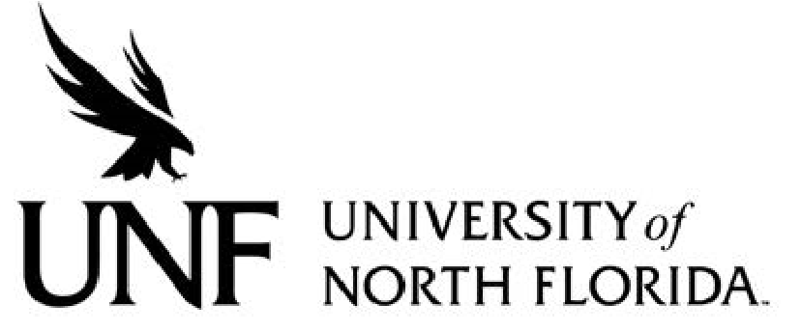 Regulation
Regulation Number: 2.1110R

Effective Date: 7/10/2023 Revised Date: n/a

Subject: Linking Industry to Nursing Education Fund

Responsible Division/Department: Division of Academic and Student Affairs

Check what type of Regulation this is:
☒New Regulation
☐Major Revision of Existing Regulation
☐Minor/Technical Revision of Existing Regulation
☐Reaffirmation of Existing Regulation
☐Repeal of Existing Regulation

- OBJECTIVE AND PURPOSE
The Linking Industry to Nursing Education (LINE) Fund provides an opportunity for each state university to receive matching funds for every dollar contributed by a healthcare partner and is governed by Board of Governors (BOG) Regulation 8.008 and section 1009.8962, Florida Statutes (LINE Authorities), which sets forth the criteria for the eligibility and use of LINE funds. This Regulation is adopted to provide for administration of the LINE program, as required by BOG Regulation 8.008.
- STATEMENT OF REGULATION
1. LINE funding proposals may be submitted by the President or designee to the BOG Chancellor’s office in accordance with the guidelines, formats, instructions, and schedule provided by the BOG Chancellor. Each LINE funding proposal must be approved by the Provost’s Office and identify and include the following:
a) A healthcare partner located and licensed to operate in the State of Florida;
b) Whether funds committed by the healthcare partner will contribute to an eligible purpose set forth the LINE Authorities;
c) How the funds will be used, including how funds will be utilized to increase student enrollment and program completion;
d) How the healthcare partner will onboard and retain graduates; and
e) How the funds will expand the University’s nursing education programs to meet local, regional, or state workforce demands, including, as applicable, advanced education nursing programs and how the funds will increase the number of faculty and clinical preceptors, and planned efforts to utilize the clinical placement process established in section 14.36, Florida Statutes.
2) The President or designee shall notify the BOG upon receipt of funds provided by the healthcare partner identified in an approved proposal before receiving dollar-for-dollar matching funds from the BOG’s grant funds, subject to funds availability.
3) Annually, by February 1 of each year, if the University is awarded LINE Funds in the previous fiscal year, the President or designee shall submit a report to the BOG that demonstrates the expansion as outlined in the proposal, delineates the use of all funds including contributions and matching funds, and otherwise provides the information, disaggregated by degree level set forth in BOG Regulation 8.008(1)(f).
4) The Provost’s Office may establish further detailed policies for LINE fund administration in accordance with the LINE Authorities and other applicable legal and regulatory authorities, including without limitation, UNF Regulations and Policies and applicable collective bargaining agreements.
Specific Authority: Section 7(d), Art. IX, Fla. Const.; BOG Reg. 8.008. History: New xx-xx-2023.

