**NOTICE OF AMENDED REGULATION**

January 6, 2025

**BOARD OF GOVERNORS**

Division of Universities

University of North Florida

**REGULATION TITLE**

Admissions – First Time in College (FTIC)

**REGULATION NO.**

2.0381R

**SUMMARY**

The proposed regulation amendment includes corrected formatting which clarifies there are two items under the Statement of Regulation section, as opposed to three, and as evidence needed for SACSCOC Standard 10.5.

**MEETING DATE**

February 12, 2025

**FULL TEXT**

The full text of the regulation being proposed is attached.

**AUTHORITY**

Florida Constitution, Article IX, Section 7(c)

Board of Governors Regulations 1.001 and 6.002

**UNIVERSITY OFFICIAL INITIATING THE PROPOSED REVISED REGULATION**

Chadwick Lockley, Director of Institutional Effectiveness and Accreditation

**INDIVIDUAL TO BE CONTACTED REGARDING THE PROPOSED REVISED REGULATION**

Stephanie Howell, Paralegal, Office of the General Counsel, showell@unf.edu, phone (904)620-2828; fax (904)620-1044; Building 1, Room 2100, 1 UNF Drive, Jacksonville, FL 32224.

***Any comments regarding the amendment of the regulation must be sent in writing to the contact person on or before Tuesday, January 21, 2025, to receive full consideration.***

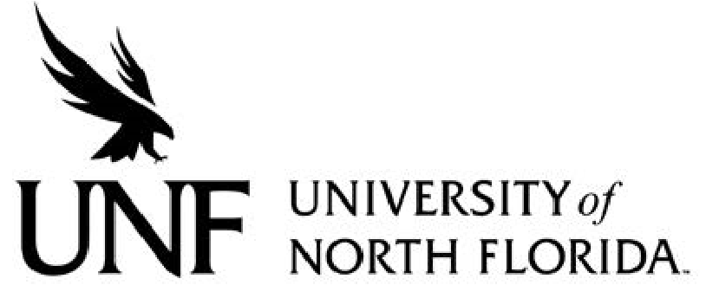 Regulation

**Regulation Number**: 2.0381R

**Effective Date**: 07/01/2008 **Revised Date**:

# Subject: Admissions – First Time in College (“FTIC”)

**Responsible Division/Department**: Academic Affairs/Enrollment Services

**Check what type of Regulation this is:**

New Regulation

Major Revision of Existing Regulation

Minor/Technical Revision of Existing Regulation

Reaffirmation of Existing Regulation

Repeal of Existing Regulation

### I. OBJECTIVE & PURPOSE

This regulation applies to first-time, degree-seeking freshmen as defined as students who have earned a high school diploma or its equivalent and have earned less than 12 semester hours of transferable college credit after high school graduation. This excludes college credits earned during high school completion through accelerated mechanisms such as IB, AICE, AP, and dual enrollment classes.

### II. STATEMENT OF REGULATION

1. The University of North Florida's regulation is in direct alignment with the Florida Board of Governors BOG 6.002 Admission of Undergraduate First-Time-in-College, Degree-Seeking Freshman, which governs decisions regarding the admission of all first-time degree seeking students.
2. The University of North Florida’s regulation is also in direct alignment with the Florida Board

of Governors BOG 6.005 Admission of Associate in Arts High School Students, which governs decisions regarding the admission of a high school graduate with a collegiate   
AA degree as a first-time-in-college, degree seeking student. Notwithstanding anything else contained herein to the contrary, the ultimate decision regarding the admission of any and all first-time-in-college students shall rest with the University of North Florida and the University shall be free to use criteria in addition to BOG Regulations 6.002, 6.005 and 6.008, as it may deem appropriate in making such admissions decisions.

Additional information regarding this regulation can be obtained from the Office of Admissions at the University of North Florida.

Approved as amended by the BOT (date) and the BOG (date).