**NOTICE OF AMENDED REGULATION**

January 6, 2025

**BOARD OF GOVERNORS**

Division of Universities

University of North Florida

**REGULATION TITLE**

Admissions – General

**REGULATION NO.**

2.0380R

**SUMMARY**

The proposed regulation amendment includes a new statement that the admission process must comply with section 1001.7415, Florida Statutes, as now reflected in BOG regulation 6.001 General Admissions, and thus needed for SACSCOC Standard 10.5.

**MEETING DATE**

February 12, 2025

**FULL TEXT**

The full text of the regulation being proposed is attached.

**AUTHORITY**

Florida Constitution, Article IX, Section 7(c)

Board of Governors Regulations 1.001 and 6.001

**UNIVERSITY OFFICIAL INITIATING THE PROPOSED REVISED REGULATION**

Chadwick Lockley, Director of Institutional Effectiveness and Accreditation

**INDIVIDUAL TO BE CONTACTED REGARDING THE PROPOSED REVISED REGULATION**

Stephanie Howell, Paralegal, Office of the General Counsel, showell@unf.edu, phone (904)620-2828; fax (904)620-1044; Building 1, Room 2100, 1 UNF Drive, Jacksonville, FL 32224.

***Any comments regarding the amendment of the regulation must be sent in writing to the contact person on or before Tuesday, January 21, 2025, to receive full consideration.***

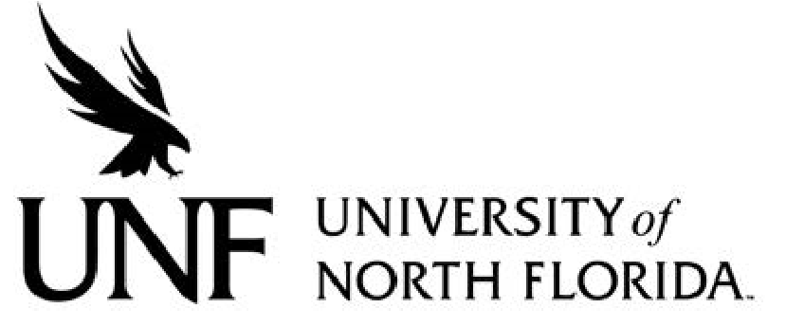 Regulation

**Regulation Number**: 2.0380R

**Effective Date**: 09/08/20 **Revised Date**:

# Subject: Admissions - General

**Responsible Division/Department**: Academic Affairs

**Check what type of Regulation this is:**

New Regulation

Major Revision of Existing Regulation

Minor/Technical Revision of Existing Regulation

Reaffirmation of Existing Regulation

Repeal of Existing Regulation

**I. OBJECTIVE & PURPOSE**

This regulation establishes the process by which applicants to the University of North Florida apply and have their application reviewed for admissions.

**II. STATEMENT OF REGULATION**

The admissions regulations of the University of North Florida are approved and adopted by the University of North Florida Board of Trustees and submitted to the Board of Governors for final approval.

1. The Office of Admissions for the University of North Florida will post the policies and procedures concerning admissions, including the decision notification process and the appeal process on the University of North Florida website as well as in the catalog.
2. The Office of Admissions for the University of North Florida will make admissions decisions without preference to any applicant based on race, color, religion, age, disability, gender, sexual orientation, marital status, national origin or veteran status.
3. In making admissions decisions, the Office of Admissions for the University of North Florida must take into consideration the applicant’s academic ability and may also evaluate students for admissions by including factors such as creativity, talent, character, and civic responsibility. Furthermore, the admission process must comply with section 1001.7415, Florida Statutes.
4. The Office of Admissions for the University of North Florida will provide notification to denied students in a timely manner. Upon written request, students who are denied will be provided with written reason for denial.
5. Every undergraduate and graduate applicant for admission will be asked to respond to a series of questions regarding past behavioral history on the application for admission.
6. A detailed and comprehensive review is required as to any applicant who is reported to have a history of past behavioral concerns by the Office of Admissions and the Graduate School. In situations of significant concern, the applicant’s file is placed on hold until a thorough background check has been completed. Upon completion of the investigation, the Judicial Hold Committee has the following options: it can approve the applicant for admission with or without restrictions, it can permanently deny an applicant from any future consideration, or it can deny an applicant with the potential to be re-considered in the future.
7. The Judicial Hold Committee will base its ultimate decision on weighing the risk of protecting the safety and well-being of the university community and ensuring no harm to the institution’s reputation.
8. The circumstances that will likely prohibit an offer of admission include, but are not limited to: the applicant’s designation as a sexual predator or sexual offender; the applicant’s history of sexual assault, abuse or harassment; an incident of a violent nature in which the applicant was involved that posed a threat or potential threat of actual harm to others; the applicant’s history of possession, distribution, and/or use of controlled substances; prior conduct by the applicant that interrupted any previous institution’s ability to carry out its educational mission; a significant behavioral history that evidences the applicant’s likely inability to meet university standards of civic responsibility and criminal convictions and sanctions against the applicant, and judicial determinations of wrongdoing by the applicant. The Judicial Hold Committee may take into consideration the proximity in time of the events giving rise to the prohibiting circumstances to the applicant’s anticipated enrollment date.
9. Any determination by the Judicial Hold Committee to deny admission or enrollment based on an evaluation of the circumstances set forth in Section II, 8 above must be consistent with applicable state and federal law.
10. An applicant denied admission to the University through the Judicial Hold Committee process may request reconsideration. Requests for reconsideration must be submitted within 10 business days of notification by the Office of Admission’s to the applicant of the decision to deny admission. Reconsideration is limited to situations in which the applicant possesses relevant evidence, information, or data that was not available at the time of the initial Judicial Hold Committee review. All such new, relevant evidence, information, or data must be documented and included with the request for reconsideration. The Judicial Hold Committee will review the applicant’s request for reconsideration in light of any such new, relevant evidence, information, or data and make a determination. The decision of the Judicial Hold Committee is final.

11) The University of North Florida Police Department will perform two reviews of

all institutional student enrollment annually through the Florida Sexual Offender/Predator Registry to ensure individual compliance and public safety.

1. Any individual applying for admission whose residency affidavit, or supplemental documents contain false, fraudulent, or incomplete statements or information may be subject to disciplinary action. Such disciplinary action may include but not limited to: denial of admission; suspension of registration; invalidation of college credit earned; invalidation of degree earned; dismissal from the university; or other disciplinary consequences. In some cases, such behavior may also result in legal implications.
2. Prior to registration, each student accepted for admissions must submit appropriate medical documentation to include, but not limited to, documentation of appropriate immunizations required by the University of North Florida. Exceptions may be granted pursuant to university policies. The University of North Florida reserves the right to refuse registration to any student whose health record or report of medical examination indicates the existence of a condition which may be harmful to members of the university community.

*Approved by the BOT (date) and the BOG (date).*