NOTICE OF AMENDED REGULATION

January 22, 2024

BOARD OF GOVERNORS

Division of Universities

University of North Florida

REGULATION TITLE:

Disruptive Behavior

REGULATION NO.:
1.0030R

SUMMARY:
The regulation is being amended to incorporate instances of violation of Florida Statute §553.865 Private Space or BOG Regulation 14.010, as disruptive behavior.

MEETING DATE AND TIME:
February 26, 2024 @ 8:30 a.m.

FULL TEXT:
The full text of the regulation being proposed is attached.

AUTHORITY:
Florida Constitution, Article IX, Section 7(c)
Florida Board of Governors Regulations 1.001, 14.010
Florida Board of Governors Regulation Development Procedures
Florida Statute §553.865

UNIVERSITY OFFICIAL INITIATING THE PROPOSED REVISED REGULATION:
Rachel Winter, JD, Dean of Students

INDIVIDUAL TO BE CONTACTED REGARDING THE PROPOSED REVISED REGULATION: Stephanie Howell, Paralegal, Office of the General Counsel, showell@unf.edu, phone (904)620-2828; fax (904)620-1044; Building 1, Room 2100,

1 UNF Drive, Jacksonville, FL 32224.

Any comments regarding the amendment of the regulation must be sent in writing to the contact person on or before February 5, 2024, to receive full consideration.

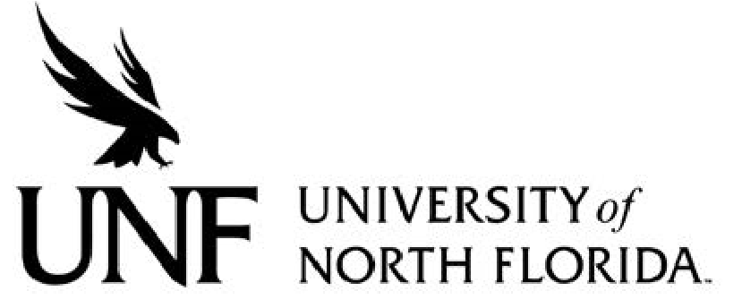 Regulation
Regulation Number: 1.0030R

Effective Date: 05/16/04 Revised Date: xx/xx/xx

Subject: Disruptive Behavior

Responsible Division/Department: Academic & Student Affairs/Dean of Students - Administration & Finance /HR

Check what type of Policy this is:
☐New Policy
☒Major Revision of Existing Policy
☐Minor/Technical Revision of Existing Policy
☐Reaffirmation of Existing Policy
☐Repeal of Existing Policy

I. OBJECTIVE & PURPOSE
The orderly conduct, processes, and functions of the University are vital to achieving the University's mission. Therefore, any member of the University Community who intentionally acts to impair, interfere with, or obstruct the orderly conduct, processes, and functions of the University are subject to appropriate disciplinary action and potential civil or criminal legal action. For purposes of this Regulation, "University Community" is defined to include students, faculty, staff, independent contractors, visitors, any other person employed or contracted with the University, and any other individual interacting with the University or premises under its control.

II. STATEMENT OF REGULATION; PROHIBITION AGAINST DISRUPTIVE BEHAVIOR
An individual who intentionally engages in any of the following conduct commits disruptive behavior and will be subject to appropriate discipline when the conduct is relevant to the orderly conduct, processes, and functions of the University.
- Violence or threat of violence to self or others;
- Theft, conversion, misuse, unauthorized use, damage, or willful destruction of University property or of the property of members of the University Community;
- Unauthorized interference with the freedom of movement of any member the University Community;
- Unauthorized interference with or impeding the rights of others to enter, use, or leave any University facility, service, or scheduled activity, or carry out their normal functions or duties;
- Intentional interference with teaching, academic freedom, or freedom of speech of any member of the University Community when the actor's conduct itself is not protected by the Constitution or other applicable law;
- Non-compliance with written or oral requests or orders of authorized University officials in the performance of their official duties;
- Providing false information to University officials, withholding required information from University officials or others, or misusing University documents;
- Possessing or using, without the prior written approval of the appropriate University officials, fireworks, explosives, dangerous chemicals, ammunition, or weapons on campus. Lawful possession of a weapon within a vehicle as permitted by Florida Statute § 790.251 does not constitute disruptive behavior;
- Creating or in any way imitating a false alarm;
- Misuse of, or interference with, fire-fighting equipment;
- Disturbing the peace;
- Endangering the health, safety, or welfare of members or the University Community;
- Unauthorized solicitation of funds;
- Misuse or unauthorized duplication of any University key;
- Violating Florida Statute §553.865 or BOG Regulation 14.010.
- Violating any federal or Florida law, rule, or regulation.

III. PROTECTION OF LEGAL RIGHTS
Nothing in this Regulation should be interpreted to infringe upon an individual's legal rights under the Constitution or applicable law. The University environment is unique in that there must be the freedom to express ideas and to foster communication on subjects that enhance the University's educational mission. Accordingly, while the University is committed to providing a learning environment that is free from disruptive behavior, the purpose of this Regulation is not intended to abridge academic freedom or to interfere with freedom of expression as guaranteed by the U.S. and Florida Constitutions. As a result, disruptive behavior does not include:
- The expression of ideas in an academic context to provoke thought or discussion on topics germane to the course and advancement of the University's educational mission.
- Engagement in debate or discourse over issues that society may find to be unpopular, offensive, or disagreeable.
- Discussing, using or displaying views, words, symbols or thoughts in an academic setting which are germane to the course and which some persons may find to be offensive.
- Other legally protected activities and statements.
Individuals must be mindful that although rights of freedom of expression and academic freedom are broad, they are not unlimited. The University will take action on conduct that goes beyond legal protections and violates this Disruptive Behavior Regulation.

IV. GEOGRAPHIC SCOPE OF REGULATION
This Regulation applies to acts conducted on or off campus when relevant to the orderly conduct, processes, and functions of the University. For information and guidelines regarding on campus commercial solicitation activity reference UNF Regulation 7.0050R Commercial Activity; Selling of Merchandise, Activities Involving Off Campus Vendors.
Specific Authority: Fla. Stat. §§553.865, 1006.60(5); BOG Regulation 14.010
Approved by the Board of Trustees 1/28/2021; revised xx/xx/xxxx

