NOTICE OF AMENDED REGULATION
May 10, 2022

BOARD OF GOVERNORS

Division of Universities

University of North Florida

REGULATION TITLE:
Camps, Programs and Other Activities

REGULATION NO.:

6.0170R

SUMMARY:

Amendments to the regulation are being proposed to support a new method and strategy to ensure the safety of all minors on campus. The Division/Department change is as a result of the full-time coordinator position that will reside in the Department of Recreation and Wellness. This coordinator position will now oversee the process with final approval shifting from the Vice President for Administration and Finance, to the Associate Provost for Faculty and Research.

FULL TEXT:

The full text of the regulation being proposed is attached.

AUTHORITY:

Florida Constitution, Article IX, Section 7(c)

Florida Statutes 409.175.

UNIVERSITY OFFICIAL INITIATING THE PROPOSED REVISED REGULATION:

Ashley Ballard, Senior Director Recreation and Wellness

INDIVIDUAL TO BE CONTACTED REGARDING THE PROPOSED REVISED REGULATION:

Stephanie Howell, Paralegal, Office of the General Counsel, showell@unf.edu, phone (904)620-2828; fax (904)620-1044; Building 1, Room 2100, 1 UNF Drive, Jacksonville, FL 32224.

Any comments regarding the amendment of the regulation must be sent in writing to the contact person on or before May 25, 2022 to receive full consideration.

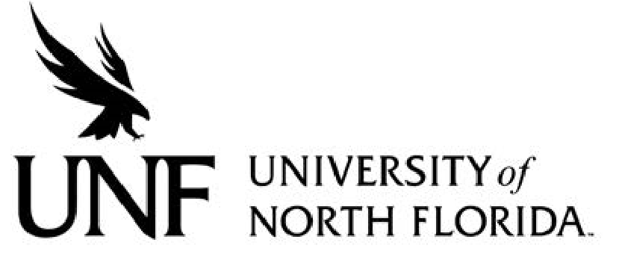 Regulation
Regulation Number: 6.0170R

Effective Date: 6/11/2013 Revised Date:

Subject: Camps, Programs and Other Activities involving Minors

Responsible Division/Department: Division of Academic and Student Affairs/Recreation & Wellness

Check what type of Regulation this is:
☐New Regulation
☒Major Revision of Existing Regulation
☐Minor/Technical Revision of Existing Regulation
☐Reaffirmation of Existing Regulation
☐Repeal of Existing Regulation

STATEMENT OF REGULATION

I. OBJECTIVE & PURPOSE
To document the regulation for operating:
• a camp, program or other activity involving minors on campus, and
• a university-sponsored camp, program or other activity involving minors at a site off-campus.
This regulation does not address activities involving minors conducted by UNF employees as outside employment. The provisions governing those activities are contained in UNF Regulation 4.0170R, Conflicts of Interest and Outside Employment/Activity.
The terms “minor” and “child” refer to individuals who are under the age of 18, but does not include emancipated minor.
II. STATEMENT OF REGULATION
Camps, programs and other activities involving minors (hereinafter “camp” or “camps”) are planned recreational, athletic/sports, arts, cultural, social, or instructional programs that are offered to children for the purpose of improving their knowledge and/or skills, and that offer experience in and/or exploration of a particular area of interest. Camps include, but are not limited to: sports, fitness, recreation, music, art, math, science, engineering, cheerleading, flag corps, religious, child education, and similar activities or areas of interest.
A. Types of Camps
1. A University-sponsored camp is one in which the University provides resources for its operation, regardless of the type of resource, fund source (i.e., E&G, C&G, Auxiliary, or Foundation), or amount of funding provided
2. Non-sponsored-Affiliate camp is a camp operated by an employee of the University who is acting independently of his/her University affiliation
3. A Third-party camp is a camp affiliated with an organization or individual external
to UNF.
III. REQUIREMENTS FOR OPERATING A CAMP ON CAMPUS
1.Approvals
Applications, including all required documents, must be submitted to the Office of Youth Programs no less than six weeks prior to the start of the camp. In no case shall a camp operate on campus until written approval has been received from the University. The Youth Compliance Programs Coordinator is responsible for reviewing all requests to operate a camp. The Youth Compliance Programs Coordinator shall coordinate, as appropriate and/or necessary, with other UNF departments/units regarding any logistics applicable to the operation of the camp. The Associate Provost for Faculty and Research is responsible for final approval of all requests to operate a camp.
2.Required Documents/Instructions
A complete description of the required documents, instructions and applicable legal and insurance requirements to operate a camp, can be found at: https://www.unf.edu/camps/Directors.aspx
3.Outside Activity
University employees who are simultaneously employed by the University and the camp, shall have received prior approval to work at the camp (i.e., an approved Outside Activity/Employment form is on file within the Human Resources online forms system).
4. Standard Operating Procedures Manual
Each camp shall maintain and make available, upon request, its Standard Operating Procedures Manual or other written operating guidelines. See: https://www.unf.edu/camps/Directors.aspx.
5. Counselor-Participant Ratio
The camp director/organizer must provide an adequate number of counselors /chaperones to supervise and escort camp participants at all times. The number of chaperones/counselors is determined by the age of the participants and the nature of the camp, but in no case shall the counselor- participant ratio be less than what is specified by the American Camps Association. See: https://www.acacamps.org/resource-library/accreditation-standards/aca-standards-relate-staff-screening-supervision-training.
6. Orientation for Employees and Volunteers
For University-sponsored and Non-sponsored-Affiliate camps, the director/organizer shall, prior to the start of the camp, provide an orientation for employees and volunteers (see: https://www.unf.edu/camps/Directors.aspx). The camp director/organizer is responsible for the content of the orientation, but in all cases the orientation shall include dissemination of information regarding child abuse reporting requirements, pursuant to HB 1355, Vulnerable Persons Reporting Act.
7. Facility Use Agreements
Camps shall be assessed a fee for the use of any UNF facility for the camp consistent with the facility fee/rental schedule approved by the Auxiliary Oversight Committee. The camp shall also be assessed a fee for custodial and other maintenance services if such fee is not included as part of the facility fee/rental schedule.
8. Background Screening Requirements for Employees and Volunteers
In accordance with Florida Statutes Section 402.302 and 435.04, and University Regulation 4.0080R Level 2 Background Checks (which includes fingerprinting) are required for all summer camp employees and volunteers prior to employment. The University has chosen to apply this requirement to all University-sponsored and Non-sponsored Affiliate camps. Each such employee and volunteer must also submit an Affidavit of Good Moral Character prior to employment/ volunteering. Contact the department of Human Resources with any questions.
9. UNF Logo or Trademark
The UNF logo and trademark are protected by copyright and cannot be used in conjunction with camp advertising by Non-sponsored camps without permission from the University. Requests to use the UNF logo or trademark by Non-sponsored camps shall be submitted to the UNF Office of Marketing and Publications and such approval, if granted, shall be noted on the camp application. Also, in order to protect the liability interests of the University, use of the UNF logo or trademark by Non- sponsored camps must also include a disclaimer that UNF does not sponsor the respective camp.
Authority: 409.175 F.S.

Amended and approved by BOT.

