NOTICE OF AMENDED REGULATION

June 3, 2021

BOARD OF GOVERNORS
Division of Universities
University of North Florida

REGULATION TITLE:
Conflicts of Interest and Outside Employment/Activity

REGULATION NO.:
4.0170R

SUMMARY:
The proposed revisions provide an updated and informative outline of a University employee’s disclosure and reporting obligations concerning potential and actual conflicts of interest.

FULL TEXT:
The full text of the regulation being proposed is attached.

AUTHORITY:
Fla. Constitution Art. IX, Section 7(c), BOG Regulation Development Procedures dated 07/21/05 and as amended 09/16/20, F.S. §1012.977.

UNIVERSITY OFFICIAL INITIATING THE PROPOSED REVISED REGULATION:
Carrie Guth, Assistant Vice President, Chief Human Resources Officer

INDIVIDUAL TO BE CONTACTED REGARDING THE PROPOSED REVISED REGULATION:
Stephanie Howell, Paralegal, Office of the General Counsel, showell@unf.edu, phone (904)620-2828; fax (904)620-1044; Building 1, Room 2100, 1 UNF Drive, Jacksonville, FL 32224.

Any comments regarding the amendment of the regulation must be sent inwriting to the contact person on or before June 18, 2021 to receive full consideration.

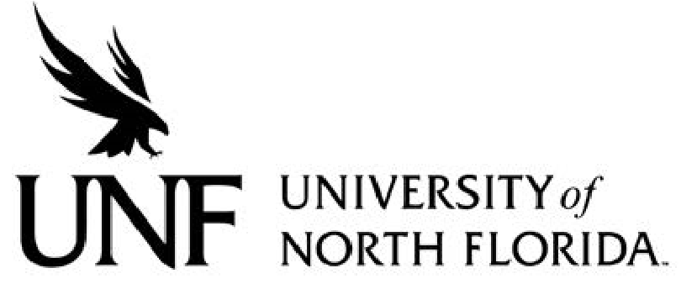 Regulation

Regulation Number: 4.1070R

Effective Date: 02/01/06 Revised Date: TBD

Subject: Conflicts of Interest

Responsible Division/Department: Administration & Finance/Human Resources

Check what type of Regulation this is:
New Regulation
x☐Major Revision of Existing Regulation
☐Minor/Technical Revision of Existing Regulation
☐Reaffirmation of Existing Regulation
☐Repeal of Existing Regulation

OBJECTIVE & PURPOSE

The purpose of this regulation is to inform University employees of their disclosure and reporting obligations as it pertains to actual and potential conflict of interest that may arise during their employment.

This Regulation is intended to complement applicable collective bargaining agreements; however, to the extent this Regulation conflicts with the terms of an applicable collective bargaining agreement, that agreement’s terms will control, so long as the agreement also complies with Florida law such as Florida Statute § 1012.977.

STATEMENT OF REGULATION

A. Overview

1) University of North Florida employees must observe the highest standards of ethics consistent with the code of ethics of the State of Florida (Chapter 112, Part III, Florida Statutes), the advisory opinions rendered with respect thereto, Board of Governors and University regulations, rules, and policies, and the laws of Florida.

2) The duties and responsibilities of an Employee's University position are considered the primary employment and generally require the Employee’s full time and attention. However, this Regulation is not intended to discourage an employee from engaging in outside activity so long as they are in compliance with this Regulation. Outside activity should not interfere with an Employee’s performance of their primary job duties. Employees earning annual leave must record annual leave for approved non-University activities that are scheduled to take place during the Employee’s normal working hours.

3) The University recognizes the valuable contributions made by individuals who are not full-time UNF employees, such as OPS employees who work less than 30 hours each week and adjuncts. While such individuals are expected to uphold the University’s high ethical standards set forth in this Regulation, to the extent such an individual believes they should be given an exception from a provision of this Regulation because UNF is not their primary employer, such an exception must be approved in writing following the submission of a Conflict of Interest Disclosure form described below.

4) Conflicts of Interest and Conflicts of Commitment are prohibited. Employees are responsible for avoiding and resolving such conflicts of interest, working in conjunction with their supervisors and other University officials. If an employee has concerns as to what may constitute a conflict of interest, they should consult with his/her supervisor.

B. Definitions

1) “Employee” is defined for purposes of this Regulation as any person employed by UNF.

2) “Conflicts of Interest” is defined as:

(a) any conflict between the private interests of the employee and the public interests of the University, the Board of Trustees, or the State of Florida, such that an independent observer may reasonably question whether the individual’s actions or decisions are partially or wholly influenced by considerations other than the best interest of the University;

(b) any activity, either alone or in conjunction with another entity, which competes with the University’s teaching, research, and service mission;

(c) any violation of the University’s Amorous or Sexual Relationship Policy 1.0070P; or

(d) any violation of the University’s Employment of Relatives Regulation 4.0050R;

3) “Conflict of Commitment” is any activity which interferes with the full performance of the employee’s professional or institutional responsibilities or obligations.

4) “Financial Interest,” for Employees engaged in the design, conduct, or reporting of research, includes anything of value other than that provided directly by the University, pursuant to Florida Statute § 1012.977. For all other Employees, it includes anything of value received in connection with an Outside Activity or Potentially Conflicting Undertaking.

5) “Outside Activity” includes. includes anything an employee does for an organization or an individual, other than the University, that is related to the employee’s expertise.

6) “Potentially Conflicting Undertaking” means any activity, compensated or uncompensated, including employment or volunteer service, done for an individual or organization, that does or could potentially cause a conflict of interest or commitment with the University. A Potentially Conflicting Undertaking need not be related to the Employee’s expertise or job duties with the University.

7) “Reportable Matter” means any Conflict of Interest, Conflict of Commitment, Financial Interest, Outside Activity, or Potentially Conflicting Undertaking.

C. Disclosure and Reporting Obligations

1) All employees must submit a Conflict of Interest Disclosure form:

(a) Annually, at the beginning of each fiscal year, even if they indicate that they have no Reportable Matter to disclose;

(b) Annually, at the beginning of each fiscal year, for previously disclosed Reportable Matters that continue from a prior disclosure;

(c) As soon as possible when proposing to engage in a new Reportable Matter; and/or

(d) As soon as possible when there is a significant change in Reportable Matter previously disclosed (nature, extent, funding, etc.).

2) Those employees not hired or physically present at the start of the fiscal year (July 1) shall promptly complete and file a new form for each Reportable Matter upon their hire date or arrival to campus.

3) Employees must submit a Conflict of Interest Disclosure and receive a determination that the Reportable Matter does not affect the integrity of the University prior to obtaining the financial interest or engaging in the Reportable Matter.

D. Review of Reportable Matters

1) Employee must complete and submit the Conflict of Interest Disclosure online form, currently found in the University myWings portal under the Employee Resources tile > Employee Forms menu > Banner Online Forms > Human Resources.

2) The online form must be approved by the appropriate vice president or designee and Human Resources. Any request to teach at another institution must also be approved by the Provost and Vice President of Academic Affairs or designee. Approval will only be granted only if a conflict under this Regulation will not occur. Upon approval or denial, the Employee will be notified of the outcome.

3) The University will maintain the approval or denial of the disclosed Reportable Matters in the myWings Banner Online Forms database.
E. Use of University Resources

An employee who wishes to engage in any Reportable Matter making use of facilities, equipment, services, intellectual property, students, or Employees of the University in connection with such outside activity must obtain prior written approval via the Conflict of Interest Disclosure online form. Approval for the use of University facilities, equipment, or services may be conditioned upon reimbursement for their use.

F. Disclaimer Regarding Acting as University Agent
An Employee engaging in a Reportable Matter must take reasonable precautions to ensure that the public, the outside employer, or other recipient of services understands that the Employee is engaging in such Reportable Matter as a private citizen and not as an Employee, agent, or spokesperson of the University.

G. APPEALS

1) If an employee believes that a request to engage in outside employment or activity has been unduly denied, a written letter of appeal may be sent to the Office of Human Resources outlining the concern, within ten (10) days of the notification of denial.

2) The Office of Human Resources will review the matter in consultation with the divisional Vice-President or Office of the Provost, and ten (10) days of receipt of the letter of appeal will notify the Employee of the determination.

3) The decision of the Office of the Human Resources shall be final regarding an Employee participating in outside employment or activity.

H. Penalties

1) If the Employee fails to disclose the Reportable Matter before engaging in it, or if they engage it in despite lack of approval, the Employee may be subject to discipline.

2) An Employee who fails to disclose an Outside Activity or Financial Interest as required by Florida Statute § 1012.977 shall be suspended without pay pending the outcome of an investigation. The investigation shall not exceed 60 days. Upon conclusion of the investigation, the University may terminate the employment of the Employee.

References: Florida Statute § 1012.977

