# NOTICE OF REGULATION REPEAL

**December 16, 2021**

## FLORIDA BOARD OF GOVERNORS

Division of Universities

University of North Florida

## REGULATION TITLE:

Compensation

## REGULATION NO.:

4.0110R

## SUMMARY:

The Board of Trustees is being asked to approve repeal of the University’s current compensation regulation, 4.0110R, in favor or a replacement policy. Although the Florida Board of Governors has two regulations regarding compensation, 9.006 (“University Personnel Definitions and Compensation”) and 9.015 (“University Bonus Plans”), neither requires the University to implement their provisions via a regulation. Having the compensation elements of the University’s personnel program in a policy, as opposed to a regulation, will allow the University greater agility in attracting and retaining diverse, well-qualified personnel through well-rounded, market-driven compensation plans. The replacement Compensation Policy will be presented to the Board of Trustees separately for its awareness and approval of the bonus-related elements it contains.

## FULL TEXT:

The full text of the regulation for repeal is attached.

## AUTHORITY:

Board of Governors Regulations 9.006 and 9.015 and

Florida Board of Governors Regulation Development Procedures for State Universities Boards of Trustees

## UNIVERSITY OFFICIAL INITIATING THE REPEALED REGULATION:

Carrie Guth, Assistant Vice President, Chief Human Resources Officer

## INDIVIDUAL TO BE CONTACTED REGARDING THE REPEALED REGULATION:

Stephanie Howell, Paralegal, Office of the General Counsel, [showell@unf.edu](mailto:showell@unf.edu), phone (904)620-2828; fax (904)620-1044; Building 1, Room 2100, 1 UNF Drive, Jacksonville, FL 32224.

***Any comments regarding the repeal of the regulation must be sent in writing to the contact person on or before December 30, 2021 (14 days from the date of posting this Notice) to receive full consideration.***

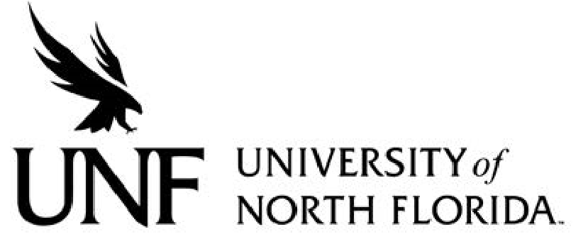**Regulation**

**Regulation Number**: 4.0110R

**Effective Date**: 2/1/2006 **Revised Date**:

**Subject: Compensation**

**Responsible Division/Department**: Administration & Finance / Human Resources

**Check what type of Regulation this is:**

☒New Regulation

☐ Major Revision of Existing Regulation

☐Minor/Technical Revision of Existing Regulation

☐Reaffirmation of Existing Regulation

☐Repeal of Existing Regulation

# OBJECTIVE & PURPOSE

# STATEMENT OF REGULATION

*References: 1001.74, FS.; 1001.75, FS. and relevant Collective Bargaining Agreements*

*History: NEW 2-1-06; Repealed 6C9-4*

*Adopted by the University of North Florida Board of Trustees as part of the University’s Personnel Program on January 26, 2006.*

*Formerly 4.006*