NOTICE OF AMENDED REGULATION May 6, 2014

DEPARTMENT OF EDUCATION
Division of Universities University of North Florida

REGULATION TITLE:
Religious Observances

REGULATION NO.:
5.0070R

SUMMARY:
The regulation is being amended so that it conforms with current University procedures.

FULL TEXT:
The full text of the regulation being proposed is attached.

AUTHORITY:
Board of Governors Regulation Development Procedure – March 23, 2006 Board of Governors Regulation 6.0115

UNIVERSITY OFFICIAL INITIATING THE PROPOSED REVISED REGULATION:
Scott Bennett, Associate Vice President Administration and Finance

INDIVIDUAL TO BE CONTACTED REGARDING THE PROPOSED Amended REGULATION:
Stephanie Howell, Paralegal, Office of the General Counsel, showell@unf.edu, phone (904)620-2828; fax (904)620-1044; Building 1, Room 2100, 1 UNF Drive, Jacksonville, FL 32224.

Any comments regarding the amendment of the regulation must be sent in writing to the contact person on or before May 21, 2014, to receive full consideration.

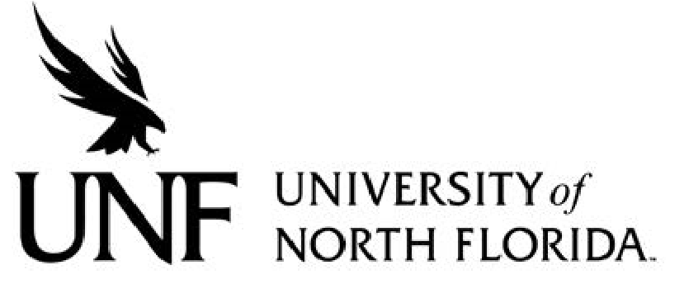
Regulation Number: 5.0070R

Effective Date: 05/07/89 Revised Date: 06/25/09

Subject: Religious Observances Accommodations for Students

Responsible Division/Department: Division of Student Affairs, Academic Affairs

Check what type of Regulation this is:
☐New Regulation
☐Major Revision of Existing Regulation
☒Minor/Technical Revision of Existing Regulation
☐Reaffirmation of Existing Regulation

OBECTIVE & PURPOSE

The University recognizes and values students’ rights to observe and practice their religious beliefs and this regulation provides a procedure in which students may seek reasonable accommodation of their religious beliefs in regard to admission, class attendance, the scheduling of examinations, major class events, major University activities, and work assignments.

STATEMENT OF REGULATION

Observing Religious Practices and Beliefs.

The University observes a student’s right to observe and practice their religious beliefs and where necessary, will reasonably accommodate a student’s religious beliefs or practices as they pertain to the following:

- Admissions – The University will not deny admission to any student because of the religious practice or belief of the student.
- Class Attendance – Any student , upon notifying his or her instructor, will be excused from class to observe a religious holy day of his or her personal faith. Such notification shall be made no later than one week prior to the holy day, or as prescribed by the instructor at the beginning of the term in his/her syllabus or other similar communication with students.
- Work Assignments – Students who are excused from class or a specific work assignment (including missing an examination or another major class event) for the purpose of observing a religious holy day will be responsible for the assignment or material covered in their absence, but they shall be permitted a reasonable amount of time to make up any missed work. Missed work shall be made up in accordance with a timetable set by the student’s instructor or as prescribed by the instructor at the beginning of the term in his/her syllabus or other similar communication with students.

- Examinations, Major Class Events, Major University Activities – No major examination, major class event, or major University activity should be scheduled on a recognized religious holy day. A recognized religious holy day is a significant day of religious observance as recognized by the highest governing body of that particular religious faith. Evidence of such recognition shall be provided by the student unless the holy day has been previously recognized by UNF on its University Calendar as a day of observance in which the University is closed in observance of the holiday.

Seeking Redress for Failure to Provide a Religious Accommodation.

Any student who believes that he or she has been unreasonably denied an educational benefit pursuant to this regulation due to his or her religious belief or practices may seek redress of the decision by filing a grievance for failure to provide a religious accommodation. Copies of this grievance form may be obtained through One Stop Student Services contacting One Stop Student Services. One Stop staff will provide information regarding the proper forum by which to appeal this academic decision.

Specific Authority: Section 7(d), Art. IX, Fla. Const., F.S. 1006.53, BOG Regulation 6.0115; History–New 5-7-89. Formerly 2.012; Amended and Approved by BOT June 25, 2009.

