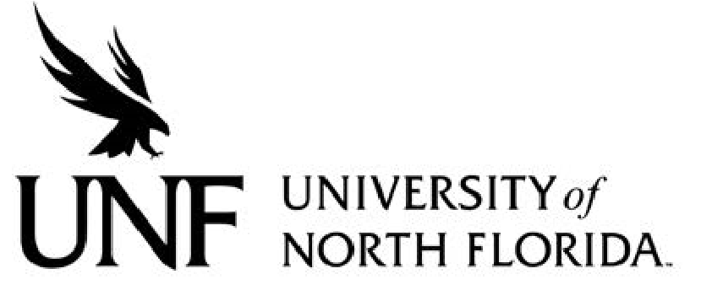
Regulation Number:

Effective Date: Revised Date:

Subject: Admissions- General

Responsible Division/Department: Academic Affairs

Check what type of Regulation this is:
☒New Regulation
☐Major Revision of Existing Regulation
☐Minor/Technical Revision of Existing Regulation
☐Reaffirmation of Existing Regulation

OBJECTIVE & PURPOSE
This regulation establishes the process by which applicants to the University of North Florida apply and have their application reviewed for admissions.

STATEMENT OF REGULATION
The admissions regulations of the University of North Florida are approved and adopted by the University of North Florida Board of Trustees and submitted to the Board of Governors for final approval.

- The Office of Admissions for the University of North Florida will post the policies and procedures concerning admissions, including the decision notification process and the appeal process on the University of North Florida website as well as in the catalog.
- The Office of Admissions for the University of North Florida will make admissions decisions without preference to any applicant based on race, color, religion, age, disability, gender, sexual orientation, marital status, national origin or veteran status.
- In making admissions decisions, the Office of Admissions for the University of North Florida must take into consideration the applicant’s academic ability, but may also evaluate students for admissions by including such factors as creativity, talent, and character.
- The Office of Admissions for the University of North Florida will provide notification to denied students in a timely manner. Upon written request, students who are denied will be provided with written reason for denial.
- Consideration shall be given to the past actions of any person applying for admissions when such actions have been found to disrupt or interfere with the

orderly conduct, processes, functions, or programs of any other university, college, or community college. If determined to be in the best interest of the University of North Florida to deny admissions or enrollment to an applicant because of the applicant’s past misconduct on or off campus, such decision can be made providing such denial is consistent with state and federal law.
- Individual’s whose admissions applications, residency affidavits, or supplemental documents contain false, fraudulent, or incomplete statements may be subject to disciplinary action. Such disciplinary action may include denial of admissions, suspension of registration, invalidation of college credit earned, invalidation of degree earned, dismissal from the university, or other disciplinary action. In some cases, such behavior may also result in legal consequences.
- Prior to registration, each student accepted for admissions must submit appropriate medical documentation to include, but not limited to, documentation of appropriate immunization required by the University of North Florida. Exceptions may be granted pursuant to university policies. The University of North Florida reserves the right to refuse registration to any student whose health record or report of medical examination indicates the existence of a condition which may be harmful to members of the university community.

Specific Authority: Florida Board of Governors Regulation 6.001 and Section 7(d), Art. IX, Fla. Const.; Formerly 6C9-3.003; Approved by the BOT and by the BOG .

2

