POLICIES AND PROCEDURES OF THE EXECUTIVE BRANCH

Nathaniel Rodefer Student Body President
Joshua Murry Student Body Vice President

Enacted September 30th, 2022

Table of Contents
- Preamble 3
- Purpose 3
- Composition of Branch 3
- Membership and Responsibilities 4
Membership Requirements 4
Appointment Procedures 4
- Duties and Powers of the Executive Branch 5
Office of the President 5
Office of the Vice President 6
Executive Cabinet 6
Executive Staff 6
Executive Agencies 7
- Workplace Standards 8
Attendance Policy 8
Time Sheets 8
Assemblies 8
Meetings 9
Dress Code 9
Transition Binders 9
- Internal Disciplinary Process 10
Censures 10
Grounds for Removal 13
Removal 13
- Amendments of the Exertive Branch Policies and Procedures 14
Authority on Amendments 14

I. Preamble

We, the elected or appointed members of the Executive Branch, in order that we may maintain and perpetuate the ideals and successes of the Student Body through an open and transparent government, and which every student may be offered equal opportunity in the purview of Student Government influence by establishing a more uniform and professional connection between the Student Body, Faculty, and Administration, do hereby ordain and establish the Policies and Procedures of the Executive Branch.

II. Purpose

The purpose of the Executive Branch shall be to represent student concerns and needs in University-wide matters through the development and promotion of programs and activities on the campus. The collective purpose of the branch includes the following:
- To be the administrative arm of Student Government.
- To research and develop programs for the advancement of cultures, clubs, organizations, and the individual student on campus.
- To provide guidance and advice to any student on any matters within the purview of Student Government.
- To uphold and enforce the Constitution and Statutes of Student Government.
- Be responsible for researching and developing programs that enhance the safety, education, welfare, and involvement of the Student Body.

III. Composition of the Branch

- The Executive Branch shall consist of the following positions and agencies:
  - The Student Body President
  - The Student Body Vice President
  - The Executive Cabinet, composed of:
    - The Attorney General
    - The Student Advocate
    - The Treasurer
  - The Executive Staff, composed of:
    - The Chief of Staff
    - The Deputy Chief of Staff
    - The Communications Director
    - The Graphic Designer
  - Executive Agency Members, composed of:
    - The Lend-A-Wing Agency, composed of:
      - The Director
      - The Assistant Director
      - The Coordinator
      - The Marketing Coordinator
    - The Osprey Involvement Center Agency, composed of:
      - The Director
      - The Assistant Director of Clubs
      - The Marketing Coordinator
      - The Involvement Coach(es)

IV. Membership and Responsibilities

Membership Requirements
For requirements for membership within the Executive Branch see: Article I, Section Four (4) of the University of North Florida (UNF) Student Government (SG)

Appointment Procedures
- Student Body President
  - For term length and limits of the Student Body President (hereinafter referred to as the President) and the order of succession for the President see: Article III, Sections Two and Three (2&3) of the UNF SG Constitution.
  - For creation of new Executive Cabinet positions see: Title III, Section Three (3) of the UNF SG System of Statutes.
- Student Body Vice President
  - For the term length and limits of the Student Body Vice President (hereinafter referred to as the Vice President) see: Article III, Section Two (2) of the UNF SG Constitution.
  - For the process regading a vacancy in the Office of the Vice President see: Article III, Section Three (3) of the UNF SG Constitution
- Executive Cabinet
  - For the appointment and confirmation process of Executive Cabinet members see: Title III of the UNF SG System of Statutes
  - 4. Executive StaffFor hiring procedures for the Executive Staff see: Title III, Section 307 of the UNF SG Statutes.
- Creation of New Executive Positions
  - For procedures regarding the creation of new Executive Branch Positions see: Title III, Section 302.3 A of the UNF SG System of Statutes.
- Executive Agencies
  - For procedures regarding hiring of Agency Directors, Assistant Directors, and Staff see: Title XI, Section Eleven Hundred and One (1101) of the UNF SG System of Statutes.

V. Duties and Powers of the Executive Branch

Office of the President
- Duties and Powers of the President:
  - For general responsibilities and powers of the President see: Article III of the University of the North Florida Student Government Constitution.
  - Additional powers of the President include:
    - Serve as a member of the University of North Florida Board of Trustees: Article IX; Section 7(C) of the Florida State Constitution; and
    - Appoint individuals to University-wide Committees (UWC); and
    - Serve on, or appoint a designee, to the Space Committee and the Student Affairs Community Council
    - Serve as an Ex-Officio member of the UNF Foundation Board following confirmation of the board.
    - Serve as an Ex-Officio member of the Alumni Association Board.
    - Serve as a Board Member for OneJax.
    - Enforce disciplinary action regarding any violations of the Executive Branch Policies and Procedures.

Office of the Vice President
- Duties and Powers of the Vice President:
  - For general responsibilities and powers of the Vice President see: Article III, Section Six (6) of the UNF SG Constitution

The Executive Cabinet
- The entirety of the Executive Cabinet shall:
  - Advise the President and Vice President on affairs under their purview, upon request;
  - Report directly to the President; and
  - Submit reports to the President, at the pleasure of the President.

- Duties and Powers of the Attorney General:
  - For general responsibilities and powers of the Attorney General see: Title III, Section 305 of the UNF SG System of Statutes.
- Duties and Powers of the Student Advocate:
  - For general responsibilities and powers of the Student Advocate see: Title III, Section 306 of the UNF SG System of Statutes.
- Duties and Powers of the Treasurer:
  - For general responsibilities and powers of the Treasurer see: Title III, Section 304 of the UNF SG System of Statutes.

D. The Executive Staff
- The entirety of the Executive Staff shall:
  - Report directly to the Chief of Staff, with the Chief of Staff reporting directly to the President; and
  - Attend events and serve at the discretion of the President.

- Duties and Powers of the Chief of Staff:
  - Submit reports to the President at the pleasure of the President on the status of the Executive Staff’s projects and activities;
  - Oversee daily operations of the Executive Staff, as well as evaluate the performance of Executive Staff members; and
  - Work with the Executive Cabinet and President on projects, initiatives and any other priority at the president’s discretion.

- Duties and Powers of Deputy Chief of Staff:
  - Submit weekly reports to the Chief of Staff on the status of their tasks and activities;
  - Serve at the discretion of the Chief of Staff in completing necessary tasks;
  - Assist with the planning and hosting of Student Government related events; and
Assist other members of the Executive Staff with their responsibilities when requested by the President or Chief of Staff.
- Duties and Powers of the Communications Director:
  - Submit weekly reports to the Chief of Staff on the status of their projects and activities;
  - Serve as the liaison between the Executive Branch and external outlets to Student Government such as but not limited to: Campus publications, external media, and other departments.
    - They may also assist other UNF SG Entities with their own media correspondences.
  - Serve as the Executive Branch webmaster;
  - Be responsible for maintaining all main Student Government social media accounts (@UNFSG on Facebook, Twitter, Tik Tok and Instagram).
    - They may also assist other UNF SG entities with their own social media pages.
  - Develop and implement marketing strategies to promote the projects of Student Government; and
  - Assist the Executive Staff with other projects as needed at the request of the President or Chief of Staff.

- Duties and Powers of the Graphic Designer:
  - Submit weekly reports to the Chief of Staff on the status of their projects and activities;
  - Create original graphic designs and digital media for all Student Government entities; and
  - Assist the Executive Staff with other projects as needed.

E. Executive Agencies
- For duties of Executive Agency Directors, Assistant Directors, and staff see: Constitution, Statutes, Executive Policies and Procedures, and Executive Agency Policies and Procedures.

VI. Workplace Standards

Attendance Policy
- Regular and punctual attendance is expected of all Executive Branch members to ensure a productive and positive work environment.
- Failure to be on time consistently will result in a Notification of Censure issued to said Executive Branch member.

Time Sheets
- Executive Branch members must establish when they will be in the office working by designating this time on their Outlook calendars. This should be noted as “Office Hours”.
- All Executive Branch members must submit, in writing, a request for time-off for any period exceeding two (2) business days at least two (2) weeks prior to the requested time off. Exceptions to this timeline may be made at the pleasure of the President.
  - Any requests shall require an approval from the President.
  - No Student Government business is to be conducted during the time of an approved request.
- All Executive Branch members must submit, in writing, a request to work remotely for any period at least two (2) weeks prior to the requested time off.
  - Any requests shall require an approval from the President and respective advisor.
  - No Student Government related business is to be conducted during the time of a request that was not approved prior.

C. Assemblies
- The President can schedule assemblies at their discretion.
- Reports shall be provided during assemblies at the pleasure of the President.
  - Reports can be formatted in either group or individual settings at the discretion of the President.; written reports may be required subject to a presidential request.
    - Following a request from the President, the party will have until the next assembly to provide the aforementioned report; a request from the President may come in formats such as but not limited to; written, online communication, mail, etc.
  - Updates regarding the Agencies shall be provided by the Vice President
  - Updates regarding the Executive Staff shall be provided by the Chief of Staff.

D. Meetings
- Directors of each agency have the power to conduct regular/bi-weekly meetings as needed.
- The Assistant Director also has the power to conduct regular/bi-weekly meetings in the absence of the Director.

E. Dress Code
- The President can construct a dress code at their pleasure.
  - This dress code is subject to change upon Presidential statements, whether it be through email, verbal, written, or otherwise.
The President may also construct a dress code for individual meetings of the Executive Branch.

F. Transition Binders
- Over the course of their term, each Executive Branch member can continuously develop a Transition Binder on their respective positions.
- The purpose of the Transition Binder is to pass along information about the position to the successor of that position and can include the following:
  - Templates and samples for important documents and emails (i.e., Purchase Requests, Room Reservations, etc.)
  - Professional tips based upon experiences from the term.
  - An opening letter to the successor, which offers words of advice, explanations, and any potential items the individual would have liked to have completed during their term.
  - A timeline providing a rough estimate on what items should be completed and when.
  - A checklist to help the successor adjust to the new position.

VII. Internal Disciplinary Process

Censures
- This section shall serve as the official internal disciplinary process regarding violations of the Executive Branch Policies and Procedures.
- Notification of Censure:
  - A “Notification of Censure” shall be a written notification which shows condemnation or disapproval of the actions or inactions of an Executive Branch member in accordance with the Executive Branch Policies and Procedures.
  - Any Executive Branch member recognized by the Constitution, Statutes, and/or Executive Policies and Procedures can be issued a Notification of Censure.
- Authority to Issue Notification of Censure:
  - The President has the authority to issue a Notification of Censure to any member of the Executive Branch.
    - . All Executive Branch members have the responsibility to notify the President of any potential violation(s) of the Executive Branch Policies and Procedures.
      - Notices shall be provided to the Executive Cabinet via written documentation.
    - . The President shall have five (5) business days to issue a Notification of Censure should they find that a violation occurred. .
  - The Executive Cabinet, with majority approval, has the authority to issue a Notification of Censure to the President.
    - All Executive Branch members have the responsibility to notify the Executive Cabinet of any potential violation(s) of the Executive Branch Policies and Procedures.
      - Notices shall be provided to the Executive Cabinet via written documentation.
    - The Executive Cabinet shall have five (5) business days to issue a Notification of Censure should they find that a violation occurred. .
- Format of Notification of Censure:
    - 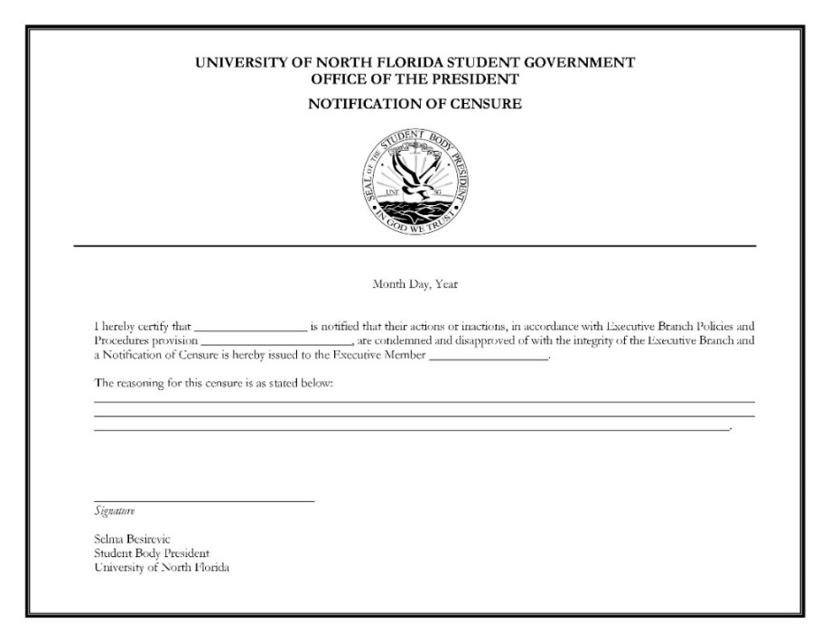Any Notification of Censure from the President shall be drafted in the following format (names serve as example):

    - Any Notification of Censure from the Cabinet shall be drafted in the following format (names serve as example):
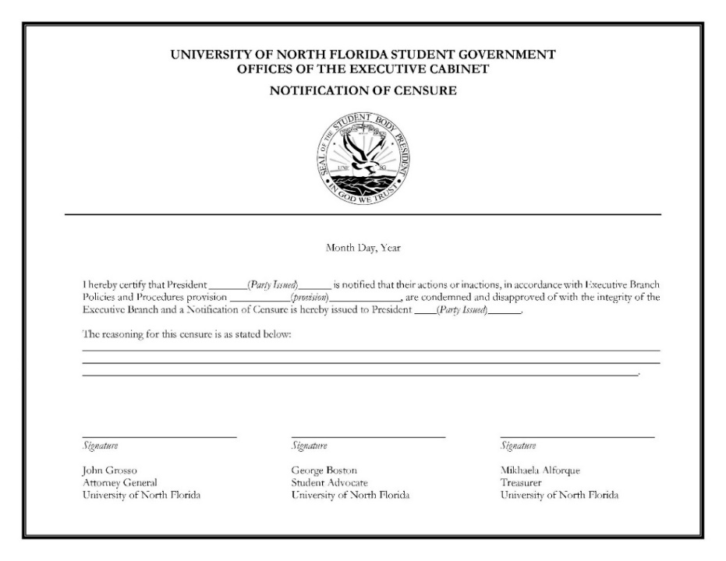

- Disposition following Notification of Censure:
  - Following the issuance of a Notification of Censure, the petitioner must deliver to the respondent a digital and physical copy.
    - A copy of the Notification of Censure shall be retained for records by the Attorney General.
    - If the respondent in question is the Attorney General, their copy shall be retained by the Vice President.
- Upon accumulation of three (3) Notifications of Censure, a judicial complaint for noncompliance shall be filed with the Attorney General, in accordance with Title VII, 700.2. and Executive Policies and Procedures, VII.1. Should these Notifications of Censure be towards the Attorney General, a judicial complaint for noncompliance shall be filed to the court by the Vice President.
  - After a judicial complaint for noncompliance is filed, if said Executive Branch member receives an additional two (2) Notifications of Censure, a second judicial complaint for noncompliance shall be filed.
  - After a second judicial complaint for noncompliance is filed, should said Executive Branch member receive any further Notification(s) of Censure, a judicial complaint shall be filed with the Attorney General for each occurrence.

Grounds for Removal
- For grounds for removal for Executive members, see: Title VII, Chapter 702.

C. Removal
- The impeachment processes of Executive Branch members see: Title VII, 703.3.
- For dismissal of Executive staff see: Title III, 308.3 B

VIII. Amendments to the Executive Branch Policies and Procedures

Authority on Amendments
- The Executive Branch is responsible for all revisions and additions to the Executive Policies and Procedures.
- The Executive Branch may make revisions and additions at any time but can only be implemented via majority approval of an Executive Assembly. Additionally, these changes must be made public.
- Any revision or addition to the Executive Policies and Procedures must be in accordance with the University of North Florida Student Government Constitution and System of Statutes, as well as any state or federal laws.

