Registering in Audit Grade Mode

Logging in:
- Access the UNF Registration System by logging in through myWings
- Select the Registration tile
- Select Registration and Course Planning

Registering for a Course in Audit Grade Mode:
- Select Register for Classes
- Select the academic term that you want to register in and select Continue
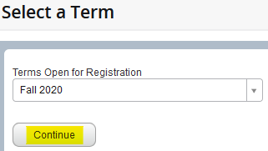
Error Messages: If you see the below message, you have holds preventing registration. You will need to clear any holds before registration can be processed.
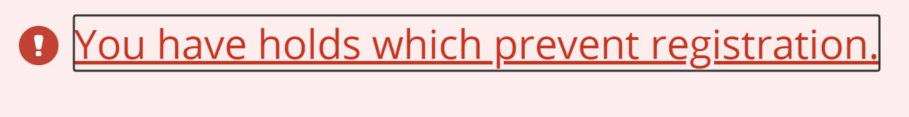
- Search for classes by CRN under the Enter CRNs tab or you can search for courses under the Find Classes tab
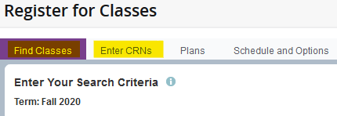
Note: Click here to access the Registration Guide webpage. More detailed instructions can be found on how to search for, plan, and register for classes.

Continue to next page…

- Added classes will now appear in the Schedule window and the Summary window of the registration system
- To register, select the Submit button at the bottom of the Summary window
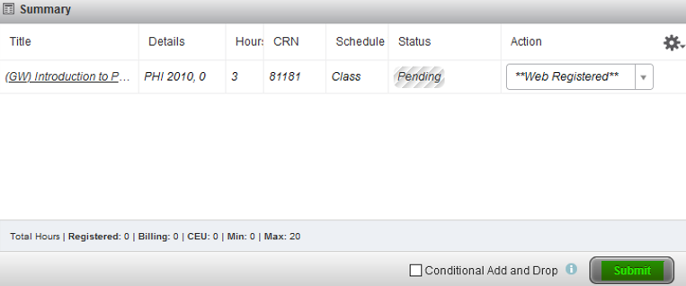
- The class Status should indicate Registered
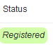

Auditing Your Registered Course(s):
Note: Changing the grading mode of a course to audit is a two-step process. You must first register for the class, then follow the below instructions.
- On the Register for Classes screen select the Schedule and Options tab
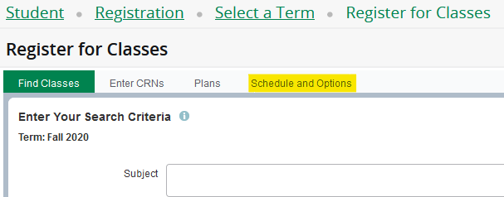
- Under Grade Mode click on the Standard Letter link for the course(s) you want to audit
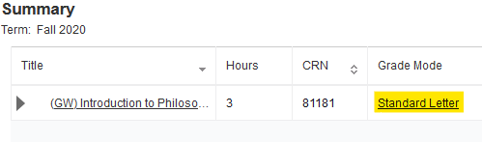
- Select the Audit grade mode drop down option for the course(s) you want to audit.
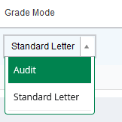
Note: Audit may not be a drop-down option. While most courses can be taken in Audit grade mode, not all courses have this option.
- Select Submit in the lower right corner of the screen
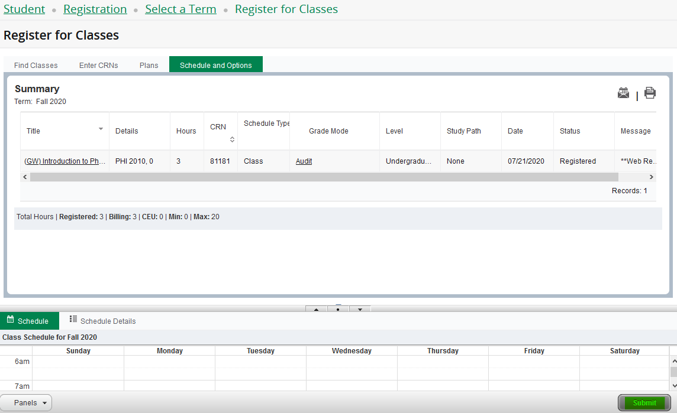
- The selected course(s) will now be in audit grade mode
Disclaimer: By registering in audit mode, please note that a letter grade will not be assigned. A grade of ‘X’ will be applied to your academic transcript.

