How to Plan and Register with the UNF Registration System

Planning for Registration:
This section explains how you can use the Plan Ahead feature and view class details.
If you have already done your course planning, click here to jump down to “Registering for Classes”.
- Access the UNF Registration System by logging in through myWings
- Select the Registration tile
- Select Registration and Course Planning
- Select Plan Ahead
- Select the academic term that you want to plan for and select Continue
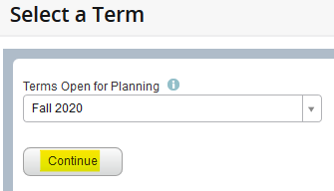
- Select Create a New Plan
- Enter in the desired Subject, Course Number, and/or Keyword
Note: Select Advanced Search for more search options
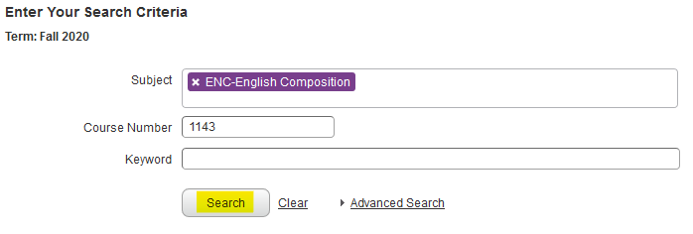
- Select Search

Continue to next page…
- The course title link can be selected to view course details
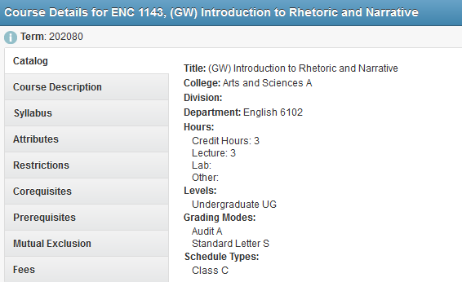
- Select either View Sections or Add Course to add this course to you plan
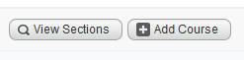
- View Sections: Displays a list of all course sections for the term. An individual class section can be added to your plan. The section will appear in your plan window when selected.
- Add Course: Adds the course to your plan without selecting a particular class section. The course will appear in your plan window when selected. During registration you will be able to select the desired class section.
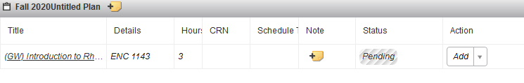
- Continue adding courses and/or sections to your plan. When finished select Save Plan.
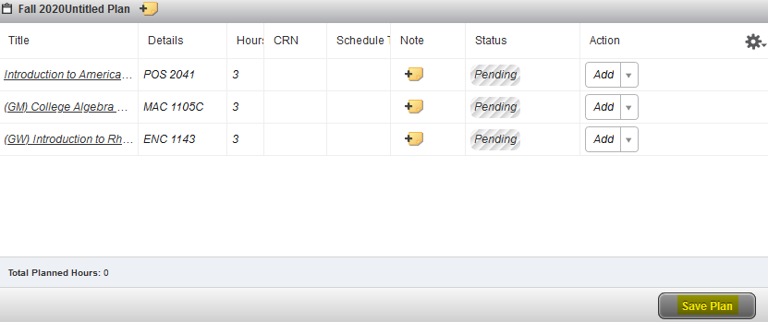
Continue to next page…

- Give a name to your plan and select Save
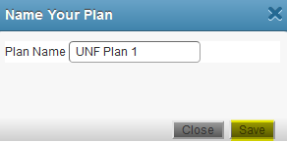
- Your plan can now be accessed in the Plans tab under Register for Classes
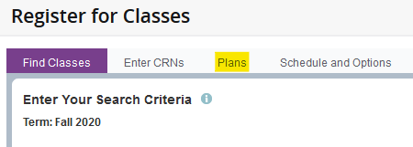

Registering for Classes:
This section explains how to register for classes using your plan.
- Access the UNF Registration System by logging in through myWings
- Select the Registration tile
- Select Registration and Course Planning
- Select Register for Classes
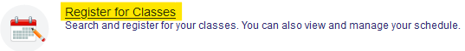
- Select the academic term you want to register for and click Continue
Error Messages: If you the below message, you have holds preventing registration. You will need to clear any holds before registration can be processed.
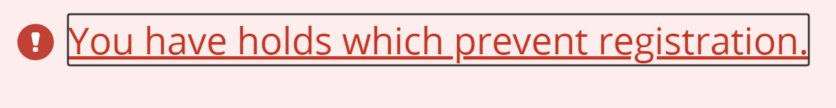
Continue to next page…
- If you previously created a plan, select the Plans tab
- If you have not created a plan, you can either search for classes by CRN under the Enter CRNs tab or you can search for courses under the Find Classes tab.
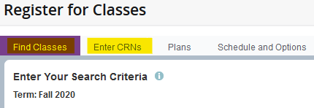
Note: Please see the above section on Planning for Registration for more information how to use the registration system search feature.
- Selected classes will now appear in the Schedule window and the Summary window
- To register, select the Submit button at the bottom of the Summary window
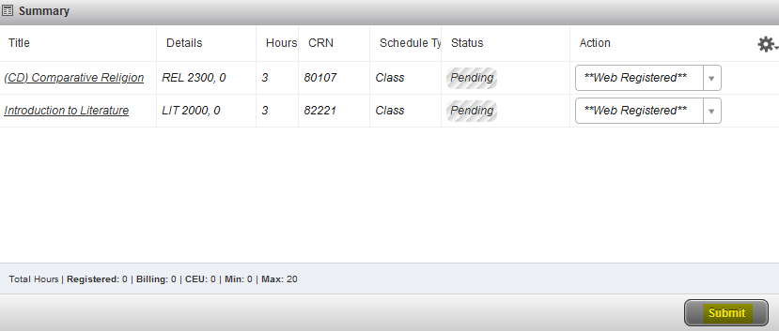
- Each class should have a Status of Registered
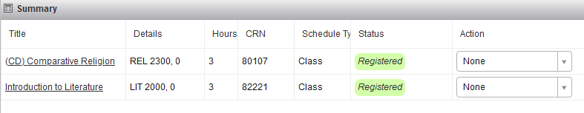
Continue to next page…
- If there are any registration errors, they will be shown in the Status column. Action will need to be taken on these courses. All other courses will be successfully registered.
- To drop/remove a course or be placed on a section wait list use the drop-down under Action. Once the desired action is selected, click Submit.
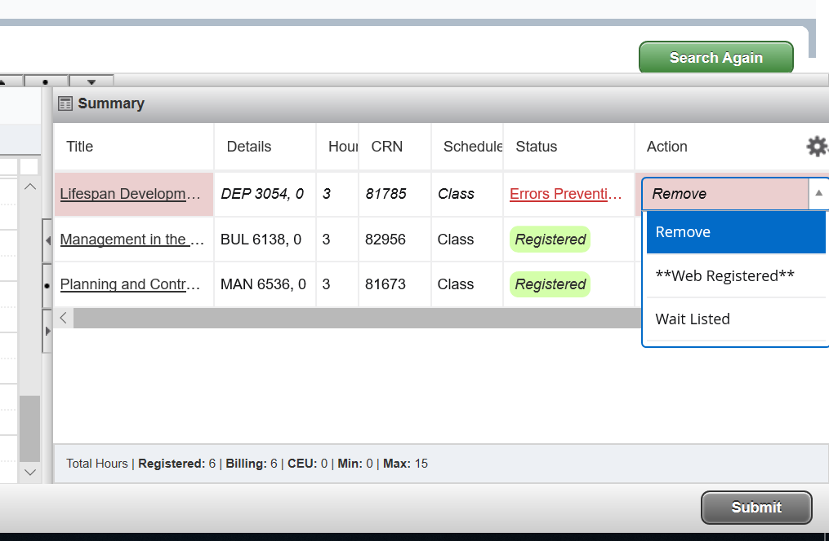
- If you’d like to print your schedule, from the Schedule and Options view, select the print icon, select printer options, and click Print.
