Entering and Changing an Incomplete Grade

Entering an Incomplete Grade
- Select Final Grades from the Faculty & Advisors Menu.
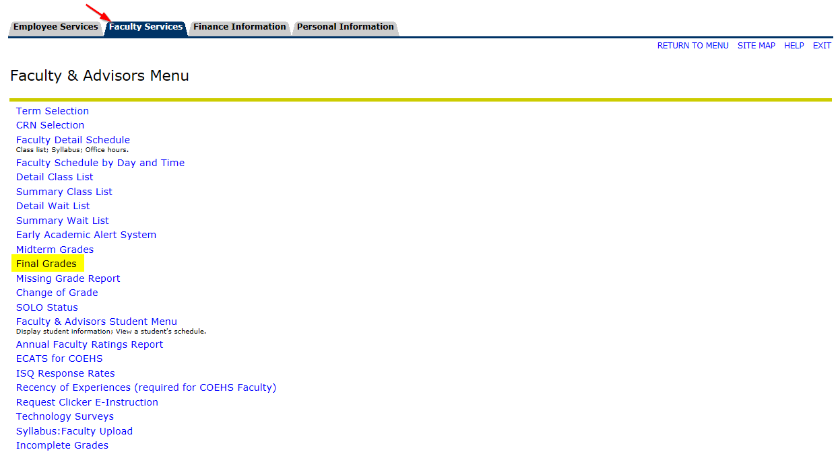
- Select the Term and CRN for the course to be graded.
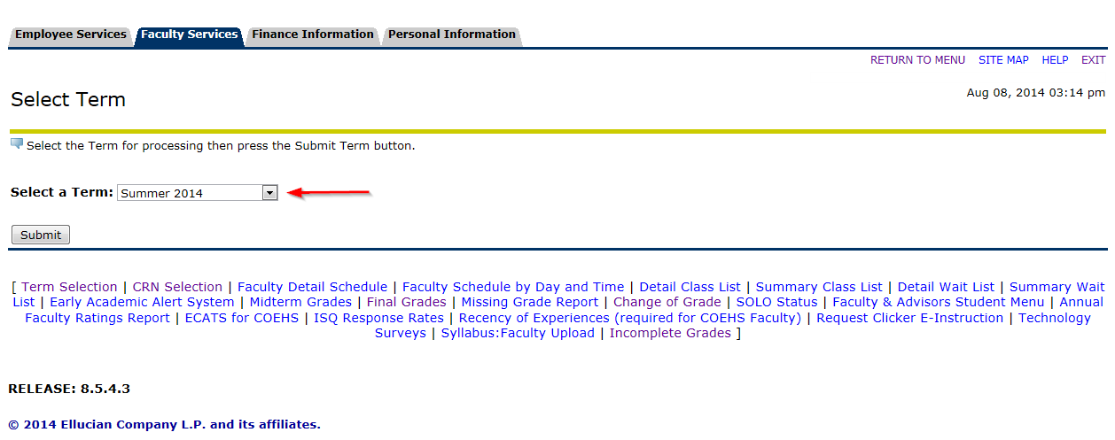

- Enter the applicable grades, including the incomplete grades, for each student.

Note: You are required to enter the Last Date of Attendance for all ‘F’ and ‘I’ grades prior to submission
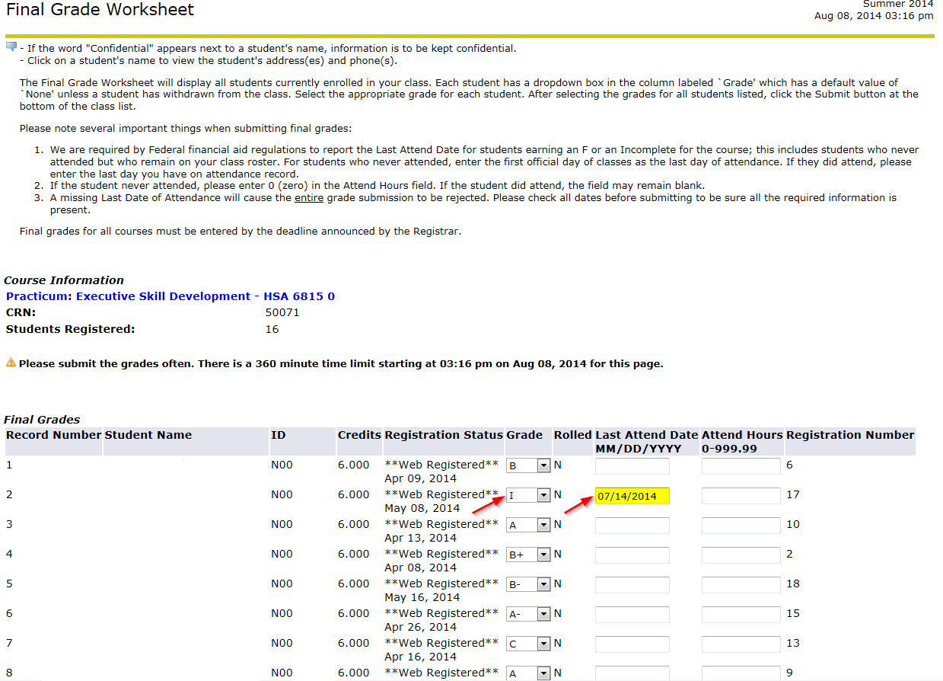
- Click Submit to enter all the currently posted grades.
- You will be prompted to submit any Incomplete grades via the Incomplete Final Grades screen. This screen displays the current ‘I’ grade and allows for you to enter a default grade and a specific extension date.

Note: The current default grade is an ‘F’ and the current default date is one calendar year from the end of term. Instructors may shorten the extension date (2 weeks for example) but it cannot be extended beyond one year per the policy.

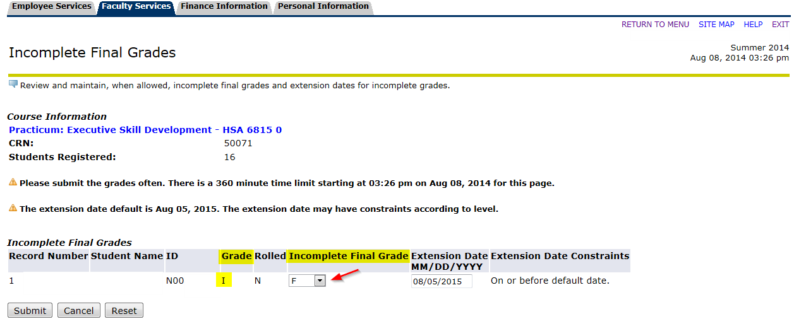
- Click the Submit button when you are prepared to make a final submission and you will return to the Final Grade Worksheet form.
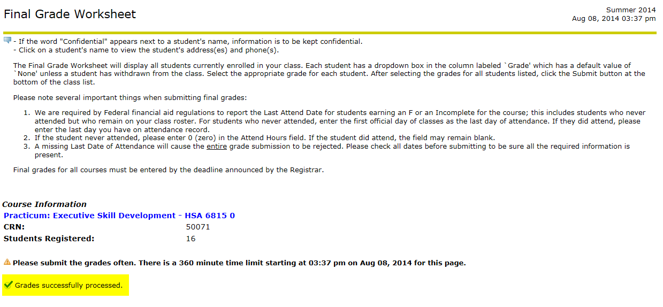

Change an Incomplete Grade
Note: All processing for changing an incomplete grade must be done prior to 11:59pm on the listed Extension Date (deadline) or the grade will roll to the Incomplete Final Grade.
- Access the Incomplete Grades section of the Faculty & Advisors Menu.
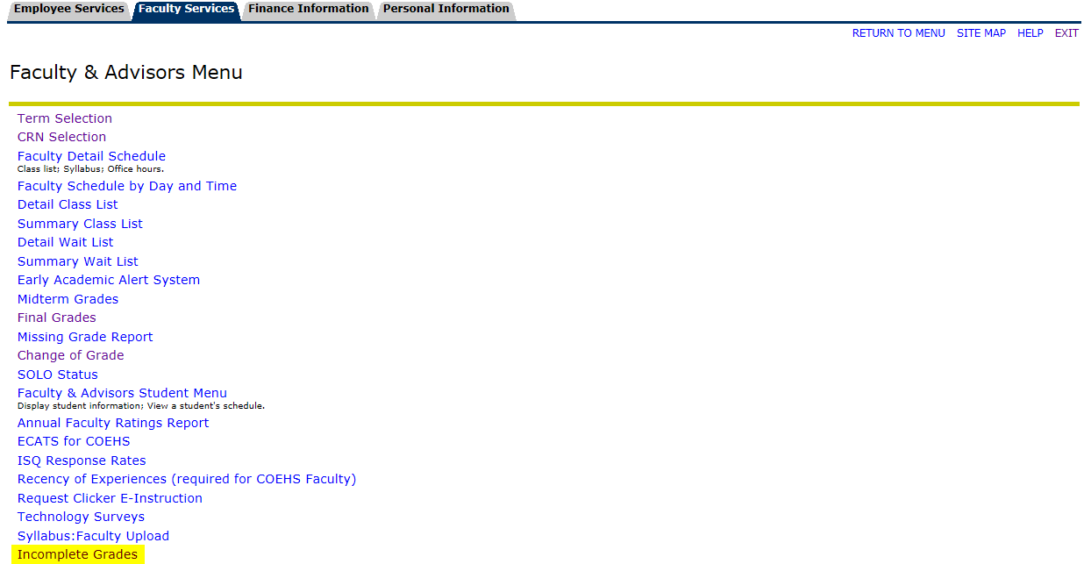
- Use the Incomplete Final Grade drop-down menu to select the new grade and then choose Submit.
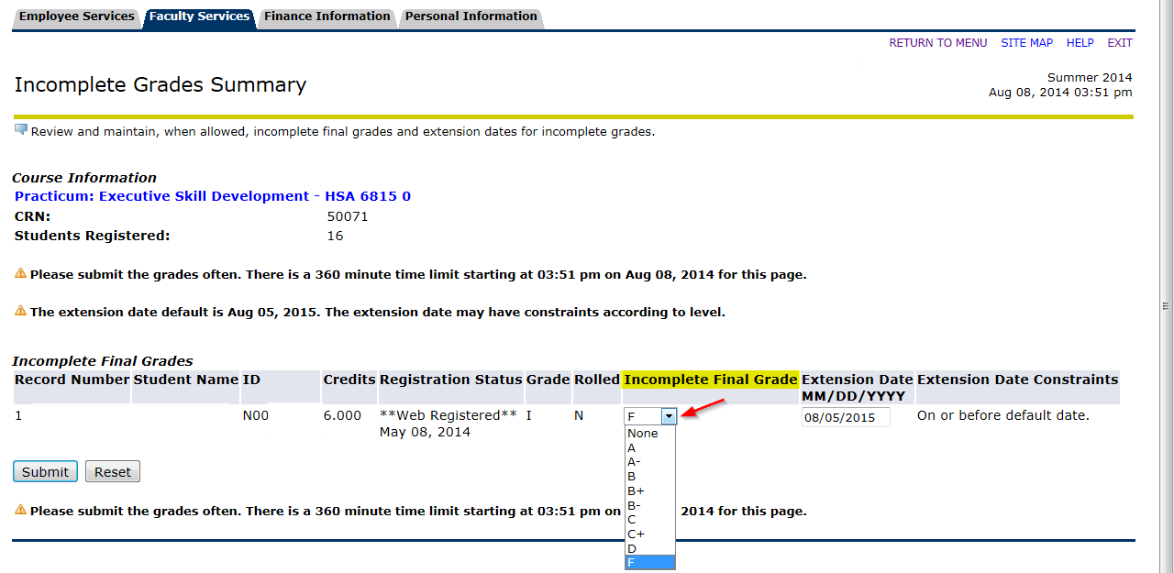
- After clicking Submit, the “Grades successfully processed” indicator will appear.
