Entering Midterm Grades – Faculty Instructions

After logging into mywings.unf.edu, select the Faculty Resources “tile.”
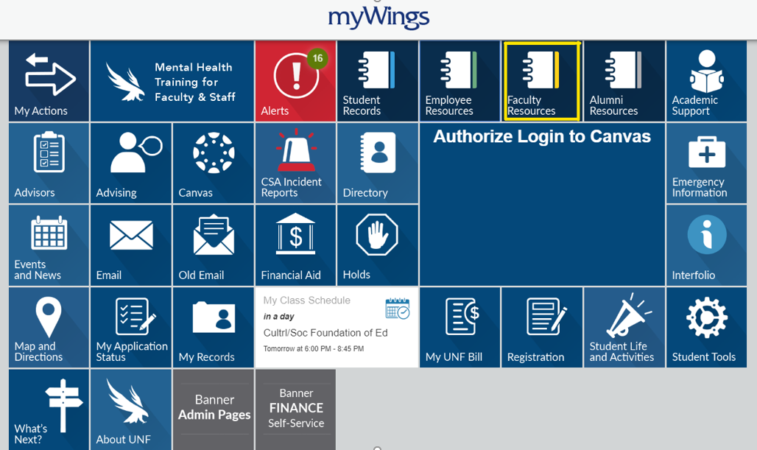

Select Faculty Self-Service on the pop-up menu.
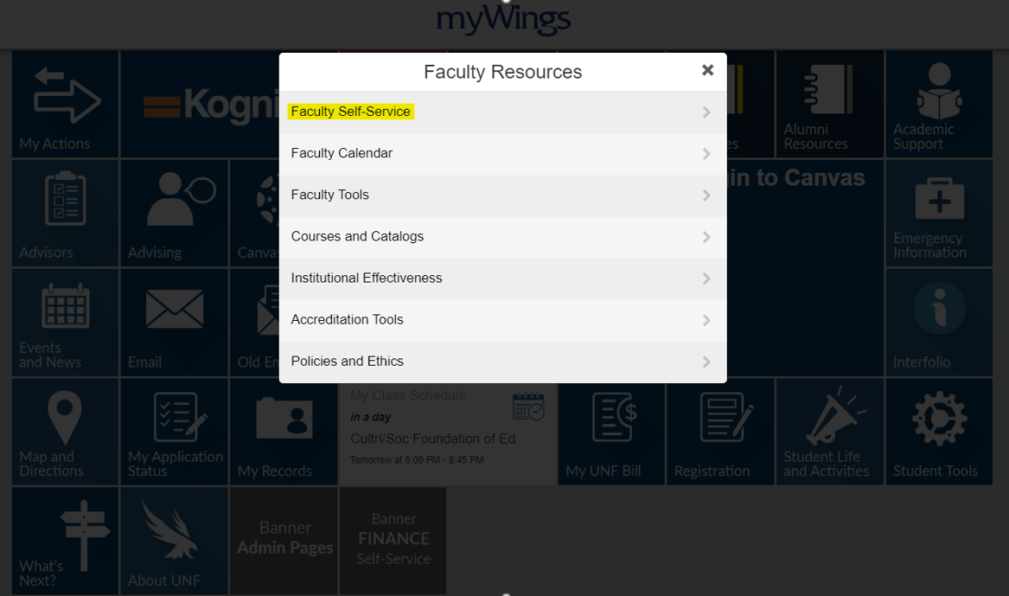

Select Midterm Grades under the Faculty Services tab in UNF self-service.
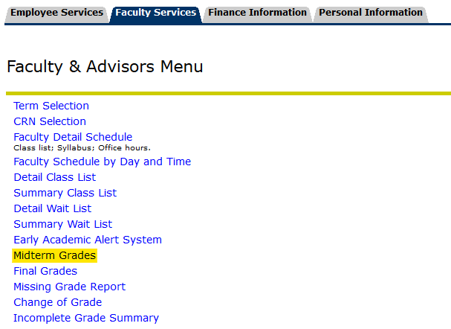

Select the term in the Select a Term drop-down list and click Submit.
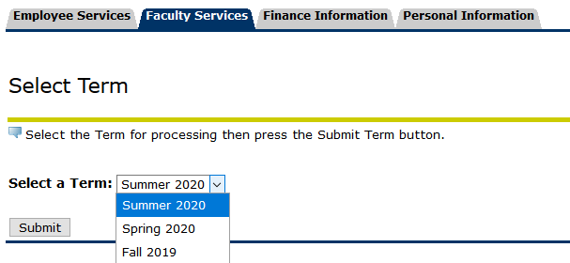

Select the CRN that you would like to enter midterm grades for and click Submit.
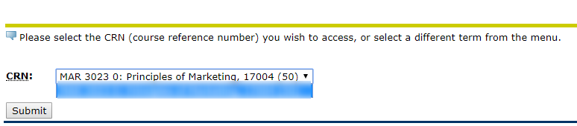

The below is a sample Midterm Worksheet screen. Students who have already withdrawn from the course will show as Not Gradable.
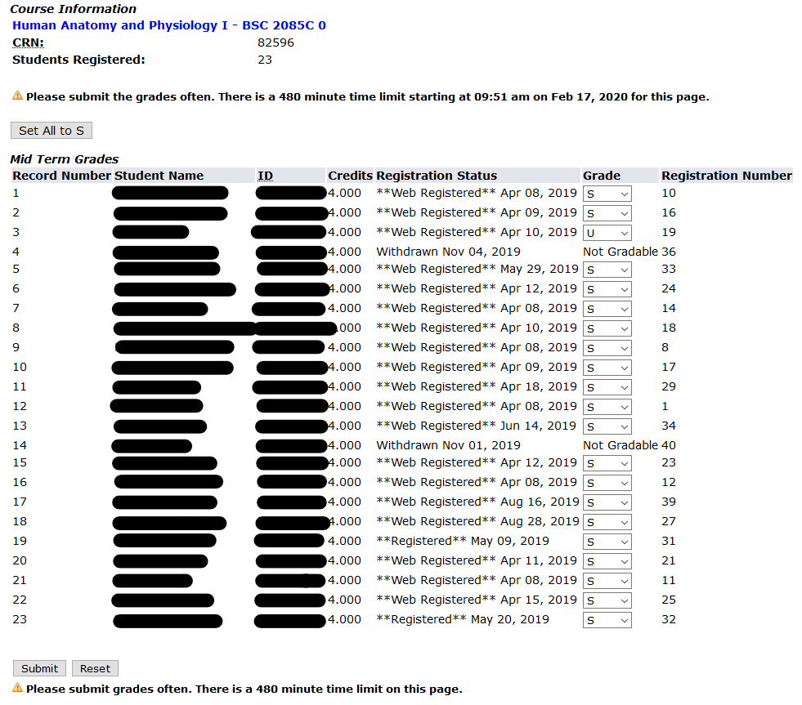

To set all Midterm Grades to S-Satisfactory, click Set All to S.

Update any unsatisfactory Midterm Grades to U-Unsatisfactory, if applicable.
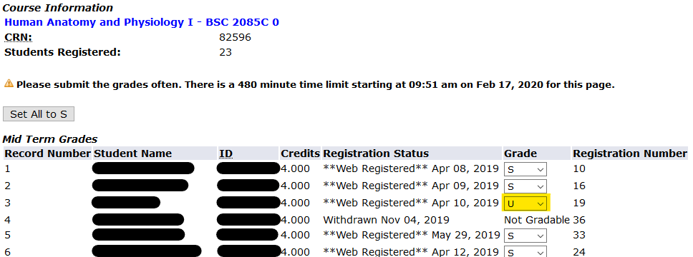

Review Midterm grades for accuracy, then click Submit at the bottom of the page.
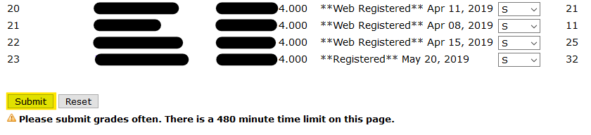

Notes:

There is no completion message after clicking Submit. A message only displays if you click Submit when no changes were made. If any updates or corrections are made, please be sure to click Submit again to save the new data.

Only 25 student records can be displayed at a time. If there are more than 25 student enrolled in your course, you will need to click the next Record Set in order to enter Midterm grades for all students.
