Entering Final Grades as Faculty

Disclaimer: These are instructions to enter grades via Faculty Self-Service. For transferring and submitting final grades via Canvas, please see the “Transferring Canvas Grades to myWings and Submitting Final Grades” instructions found on the Faculty and Staff Resources webpage. Please contact CIRT for any other questions regarding the Canvas Grade Transfer tool.

Logging in and Accessing the Final Grades Worksheet
Access the Final Grade Worksheet by following these steps:
- Log in to myWings at http://mywings.unf.edu.
- Select the Faculty Resources tile.
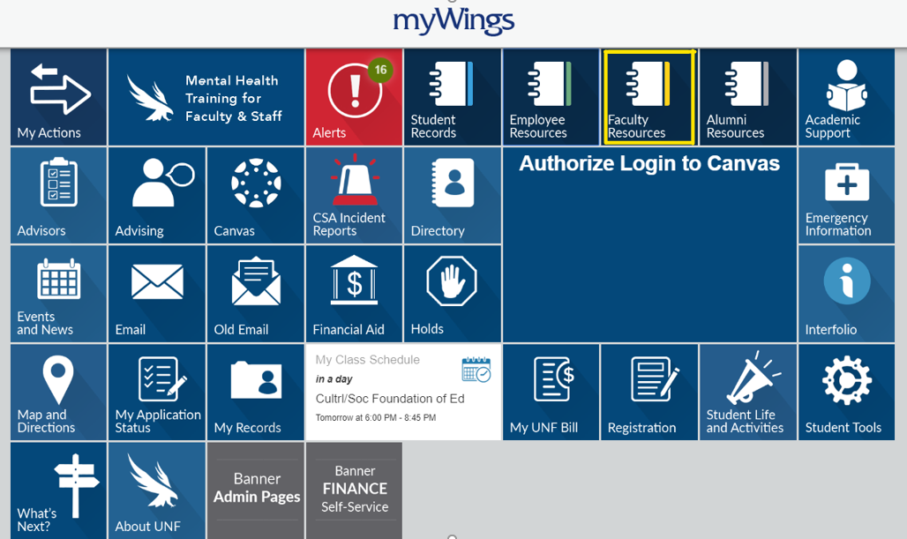
- Select Faculty Self-Service in the pop-up menu.
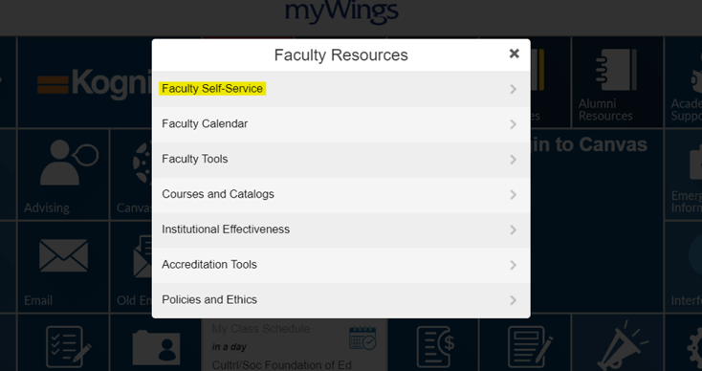
- Select the Final Grades menu option under the Faculty Services Menu.
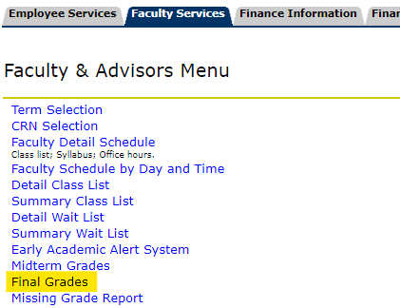
- Select the Term and CRN for the course you are submitting for.

Using the Final Grades Worksheet
- Enter final grades for all students on your roster.
- Last Attend Date – Adjust this date only if the student is receiving Fail (F) or Incomplete (I) and the date already displayed is incorrect. Do not adjust or delete this date for any other students. A missing date will cause your entire entry to be rejected.
- Attend Hours – In the example below, the grades for students 2 and 4 require you to enter “Attend Hours” along with the last attend date in the MM/DD/YYYY format. Students who earn a F or I grade require this additional information. You will need to enter the hours attended in the Final Grade Worksheet before submitting final grades.
  - Instructors can use the date of the last test or assignment submitted by the student if they do not regularly record class attendance.
  - If the student did not attend the first day of class, please use that date as the Last Attend Date and list the Attend Hours as 0.
  - If the student attended only the first day of class, please use that date as the Last Attend Date and list the Attend Hours as 1.
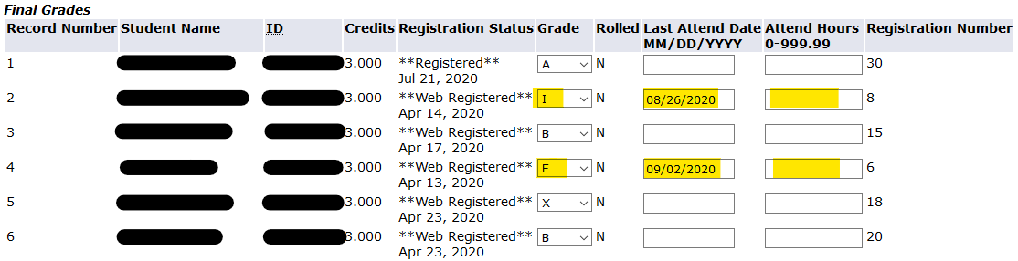

- Students who have withdrawn from the course will appear as Not Gradable.
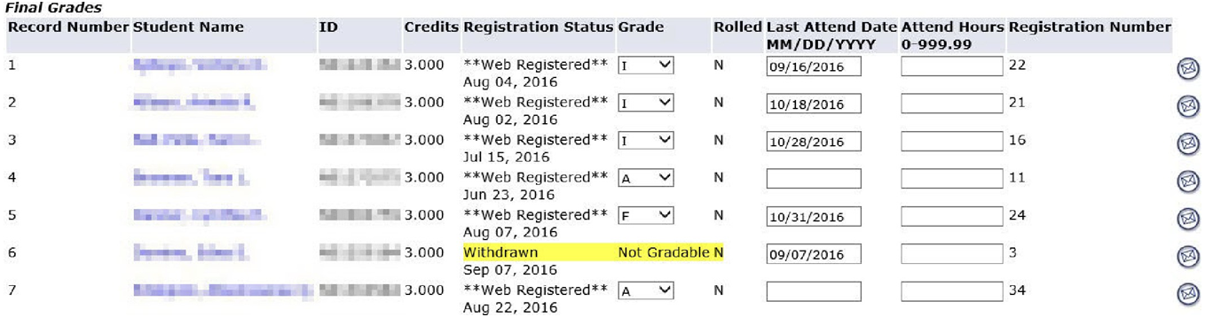
- Once you have made the appropriate entries on the Final Grade Worksheet, please review and submit.
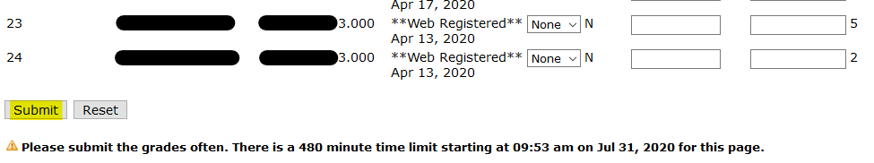
- Make sure to confirm your submission at the top of the Final Grade Worksheet.
