How to Access the Missing Grade Report

Step 1:
Begin in myWings Banner Self-Service by accessing the Faculty and Advisors section under your Personal Information tab.
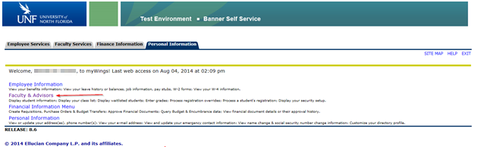

Step 2:
Choose the Missing Grade Report from the Faculty and Advisors menu.
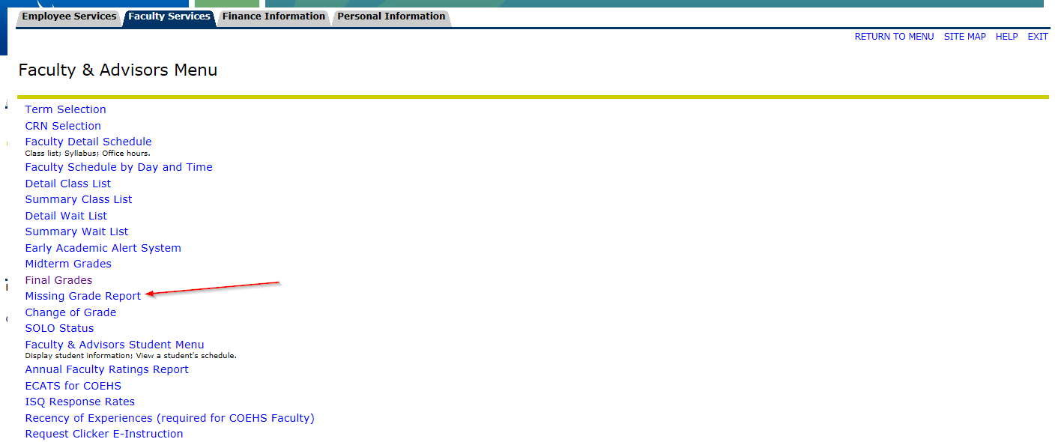

Step 3:
Use the drop-down menu to select the term.
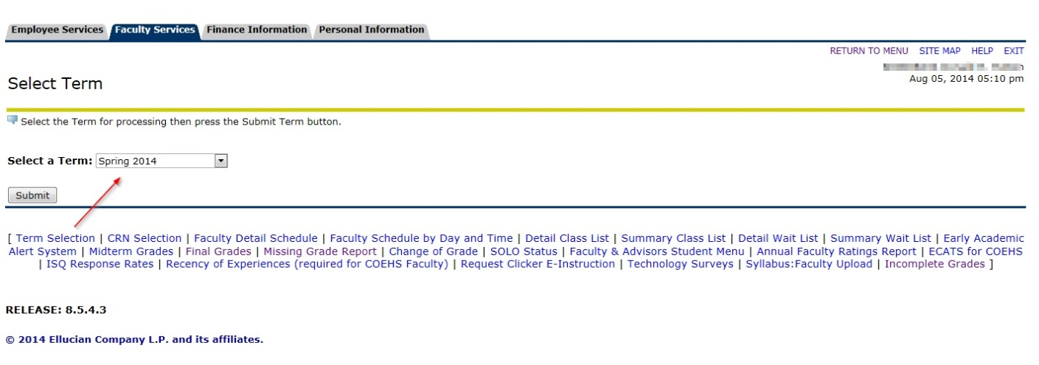

Step 4:
Choose the correct CRN from the Missing Grade Report output.
