Faculty Alpha List Process in Self-Service

To access the faculty alpha list, open Administrative Applications in Employee Self-Service.

Click on the Catalog Schedule menu.
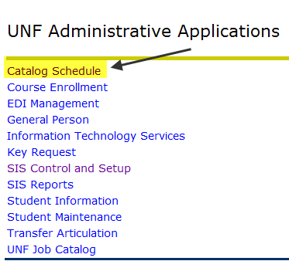

Click on Faculty Alpha List. Before the input period, you will get a message that the process is closed. Once the input period begins, you’ll see some options.
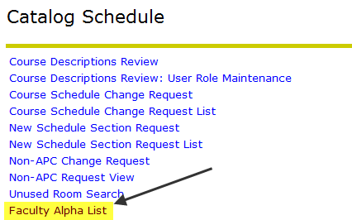

Once the input period begins, you’ll choose your term and department. Click Select.
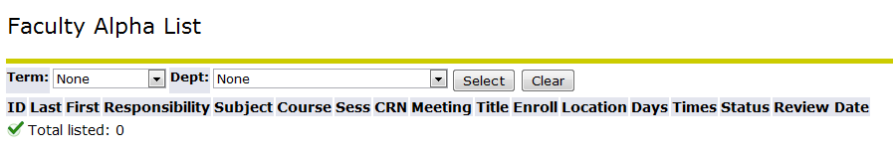

Your schedule for that term will appear. The classes without instructor information appear at the top. Canceled classes also appear at the top, but you cannot click on them.
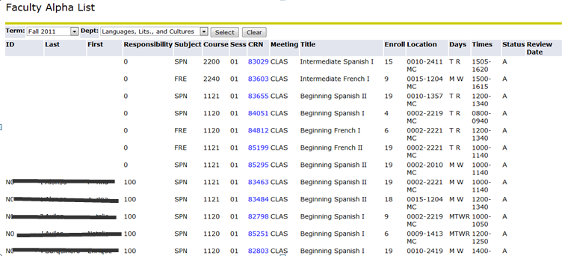

Click on the CRN of the class you wish to process.

Enter the N number of the instructor into the UNF ID field. If you need to search for an N number, click on the magnifying glass next to the field.

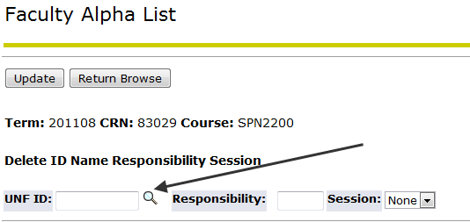

Enter the percentage of responsibility the instructor will have for the class. You must enter whole numbers only.

Select the class Session for which that person is responsible. Most classes will have Session 01 only. Classes with labs or multiple meeting patterns may have Session 01, 02, 03, etc.

Once all information is entered, select the Update button.

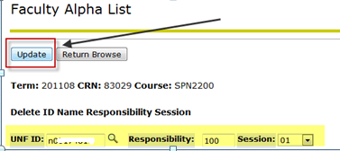
This is a successfully updated record:
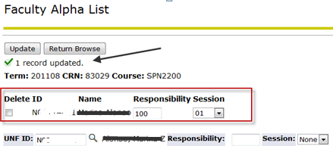

If there are multiple instructors to attach, repeat the process for each person and divide up the percentage of responsibility accordingly. For example, if you have four students being supervised by four different instructors, each will get 25%. Please note: Until you enter all instructors, you will get a message that the percentage doesn’t equal 100 and your entry hasn’t been saved. It will save everything once you’ve entered all instructors and the total does equal 100%.

If you need to remove an instructor, select the Delete checkbox to the left of the instructor’s N number and click on Update.

When you are done processing a class, click on the Return Browse button to return to the main list.
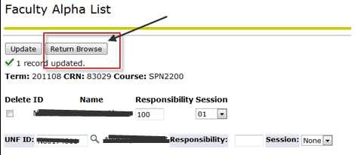

Once you return to the main list, you’ll see your entry in alphabetical order below and there will be a Review Date in the far right column.
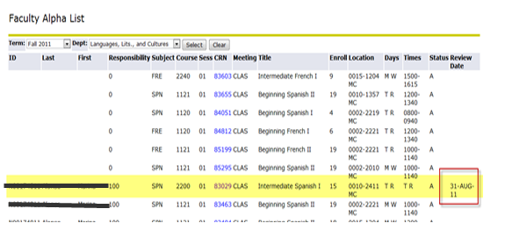

Continue entering instructor data or correcting existing instructor data until all courses are assigned.

Instructions for this process can also be found within the application itself by clicking on the HELP link at the top right of any page.
**Please note that your entry will not be immediately reflected in Course Enrollment. The instructor information added via this process will be batch loaded into Banner after all entries are received and it will be reflected in Course Enrollment at that time.**
The turnaround time for this process is one week in fall and spring terms, but it will be open longer in summer to accommodate processing for A and B terms.

