Entering Final Grades As Chair
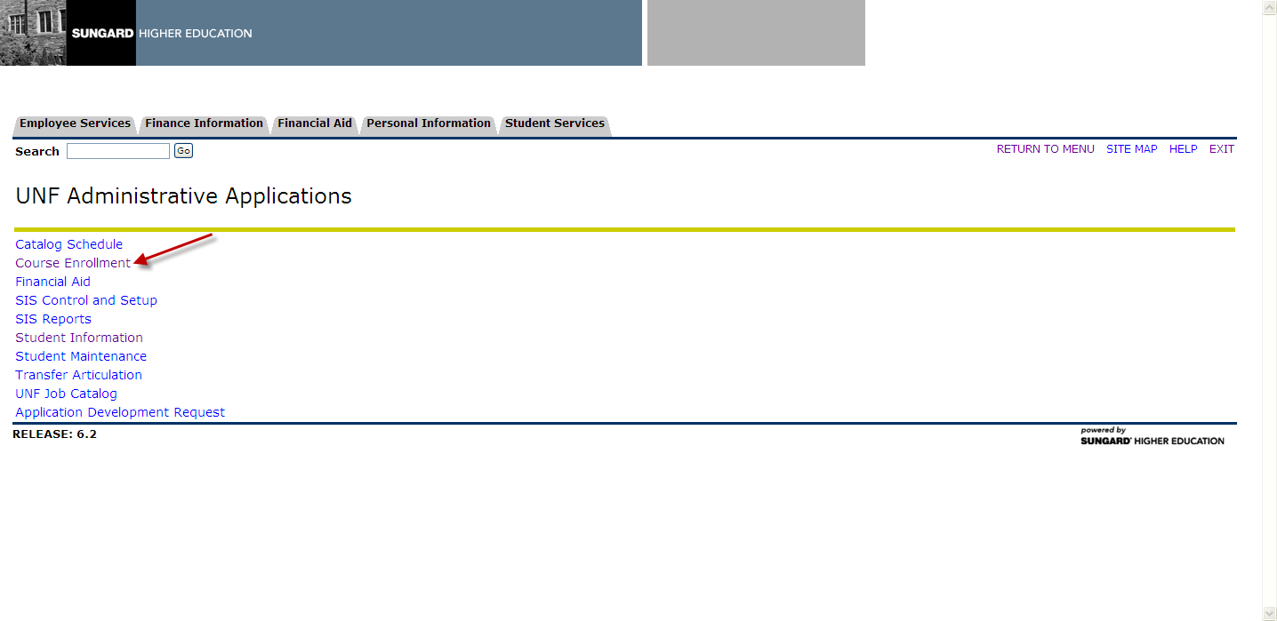

Choose Course Enrollment under UNF Administrative Applications

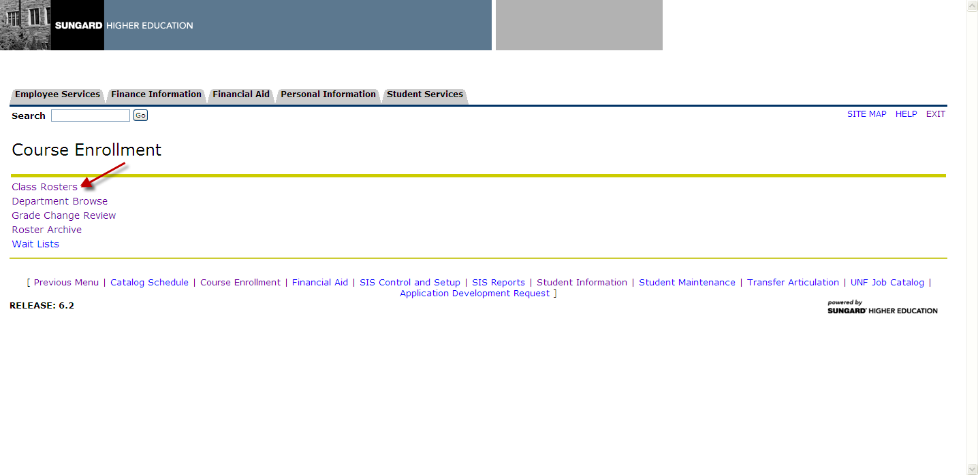

Choose Class Roster under Course Enrollment and then click on the CRN that requires grading.

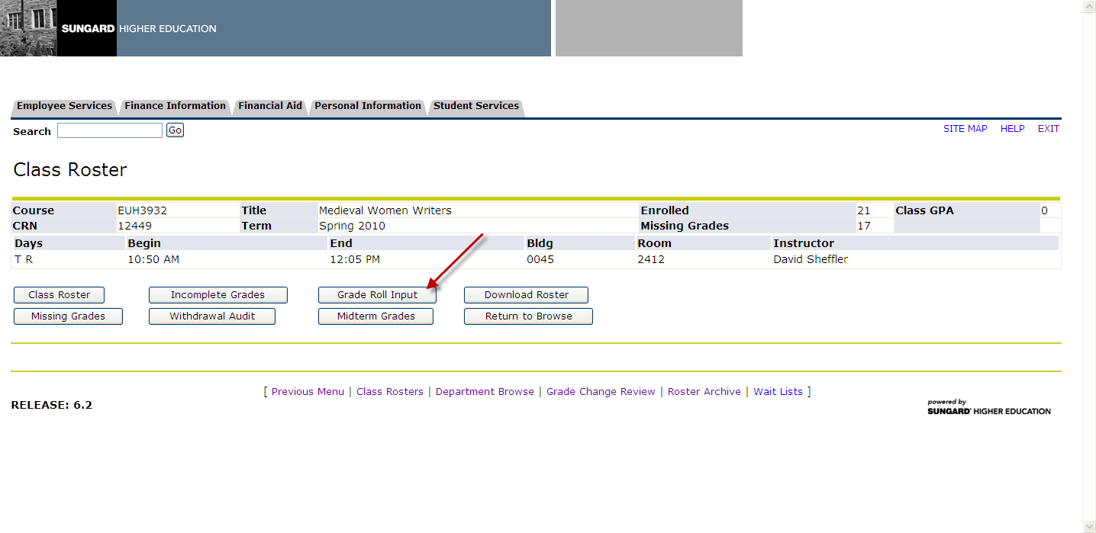

Once you select the CRN you will see several options for the course. Select Grade Roll Input in order to submit final grades.

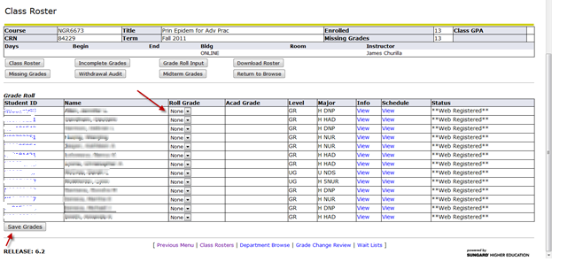

The roster and the drop-down grading option will appear for those students with missing grades. Click Save Grades once you complete the process.

