# Course Fees Review in Admin Apps – Catalog Schedule menu

Course Fees Review can be found on the Catalog Schedule menu in Admin Apps. Once you click on the link, you’ll see this screen:

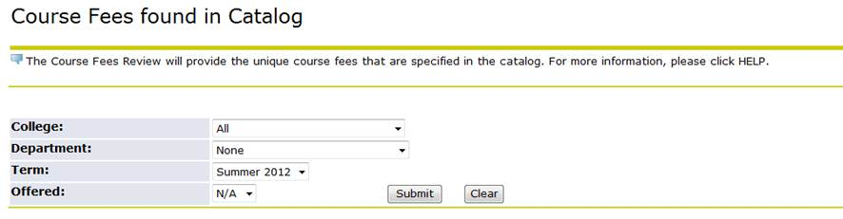

1. Select your College.
2. Select your Department.
3. Select the Term.
4. “Offered” refers to whether the course is offered for the chosen term. If you want to see all courses with fees regardless of whether they are offered, leave the option as N/A. If you only want to see what is currently being offered on the schedule, select YES from the menu.
5. Click the Submit button.

*NOTE: Courses with more than one fee appear on multiple lines, one for each fee.*

*NOTE: If your department does not have any course fees for the term selected, your department will not appear in the drop down menu.*

You can choose to open an Excel sheet with the information displayed. The link is displayed below the parameters as shown here:

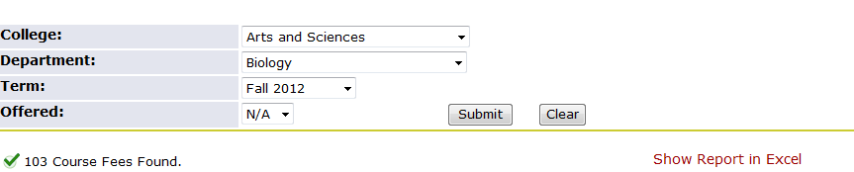

As always, there is a HELP link at the top right of the page with more information.