Course Descriptions Review

To access the application:
- Log on to myWings.
- Click on Employee Self Service.
- Open UNF Administrative Applications and select Catalog Schedule.
- Click on Course Descriptions Review
- Select your department and click Submit.

You will see a list of active courses for your department. Each course will have a status associated with it.
  - Not Started – Courses that have not been edited yet.

  - In Progress – Courses with edits made but not sent for approval.

  - Pending Approval – Courses that have been edited and submitted to the Approver.

  - Approved by Dept – Courses that have been accepted by the department’s Approver and are waiting on review by Enrollment Services.

  - Returned for Correction – Courses that have been returned for further edits by Enrollment Services (could be due to an APC issue).

  - Loaded into Banner – Courses that have approved descriptions and have been moved into the system. The process is complete for a course in this status.

Click on the course that you wish to review and edit. You will see the Current Description as it exists in Banner and an editable text box in which you make your corrections – the Corrected Description box. If you have no edits to make, simply click Submit to move the course forward to the next level. Please note that this process is to make grammatical/punctuation types of corrections only. No content changes can be made. For instance, you can make a fragment into a complete sentence, but you cannot change the meaning or key words in the sentence. In the example below, you could change the first sentence to begin “This course is a survey of”, but you cannot remove the word “epistemological” since that would be a content change.
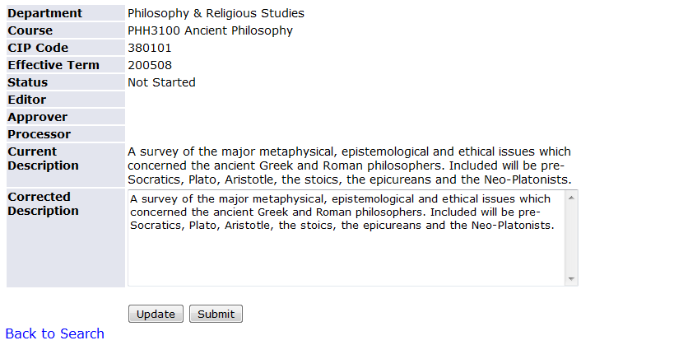

As you make edits, you can save them by clicking Update. Once all edits have been made, click Submit to move the course to an Approver for review. Please note that if you are serving as BOTH the Editor and Approver for your department, you’ll need to complete the process as Editor before you’ll get the option to submit the course to Enrollment Services as an Approver.

You’ll see a confirmation message at the top of the screen that the course has been successfully submitted to the Approver. If you are also an Approver, you just need to click the Approve button to submit the course to Enrollment Services. If you are an Editor only, you will not have the option to go any further. Please note that there is a space on the screen for Editor, Approver, and Processor. This will allow you to see who processed the course in each of those capacities and the date it occurred. In the example below, this course has been submitted by the Editor on 6/29/11.

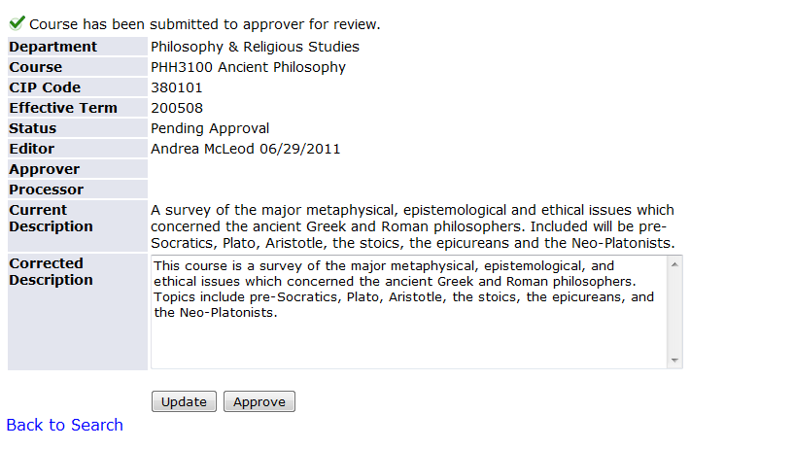

Once the Approver has submitted the course, you’ll see no more buttons at the bottom of the screen and you’ll see a message at the top confirming a successful submission of the course.
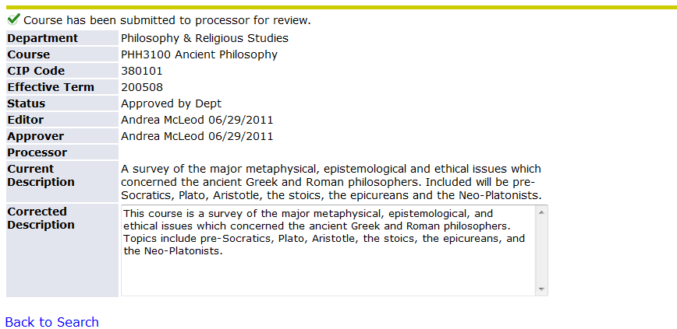

If a course needs to be returned by Enrollment Services, the Approver will receive an email detailing which course is being returned and why. Open your list and click on the course to make the necessary edits to re-submit. The Return Reason also appears on your screen:
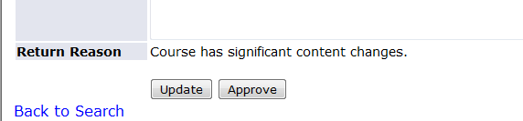
Once your edits are done, click on Approve to re-submit. If you need to make edits without submitting yet, click on Update to save those changes until you are ready to re-submit.

When your course is complete, you’ll see the status change to Loaded into Banner. If you click on the course, you can see the Editor, Approver, and Processor with dates and the final description.

