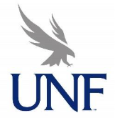 UNF Constitution Jurisdiction Committee
Agenda
November 10th, 2025, 11:30 AM
Zoom: https://unf.zoom.us/j/86373893331?pwd=aTRaq5SPLtkCgDMs0e9StmMjiFliMU.1

- Call to Order
- Introductions
- Review of Constitution and Proposed Updates (potential action item)
- Future Meetings
- Adjourn

