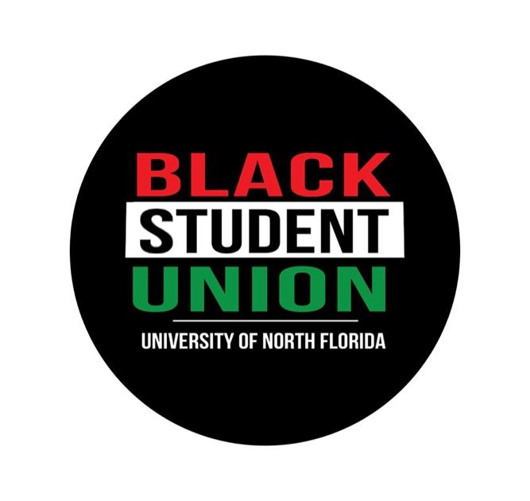

June 9, 2020

To the University of North Florida Students, Administration, Alumni, and Greater Community,

For over 400 years, Black people have endured countless acts of injustice on the basis of our skin color. We have been enslaved, economically disenfranchised, mass-incarcerated, red-lined, and had our civil rights continuously suppressed. With centuries of collective political action and individual resistance behind us, one would assume drastic changes in the conditions of our survival.

Yet, here we are again addressing more instances of police brutality and systemic racism on Black lives. Unfortunately, an excessive force led to the murder of George Floyd; lack of protocol led to the murder of Breonna Taylor; White fear led to the murder of Ahmaud Arbery; and mental health issues led to the murder of Troy McDade and Manuel Ellis.

These horrific events sparked a worldwide call for justice, not only for those listed here but also for all of the Black lives that we have lost along the way. Now, more than ever, is the time for everyone to use their voice to speak out against the injustices, including overt and covert racist behaviors, plaguing Black communities around the globe. We stand in solidarity with our Black kin on the front lines, and our non-black POC and White allies who say enough is enough.

It is crucial to remember Black people are an integral piece of the puzzle that is the United States. Our ancestors’ sweat and tears nourished the soil this country was built upon. Our ancestors’ blood was shed in the fight against racism and injustice. We honor their sacrifices as we remember their fighting spirit lives in us.

It is our duty to honor their work as we carry on with ours. This fight, which began before the inception of the United States, must end with our generation. We must ensure future generations will not have to write letters like this one. We must rebuke the fear of untimely death because of our skin color.

As an organization that was founded on Black excellence and prioritizes the advancement of our community, we call upon our members and the broader community to join us in the struggle.

In conclusion, the University of North Florida’s Black Student Union sends our deepest condolences and sympathy to the families and friends of Black people slain because of institutionalized racism. We will continue the necessary work to ensure justice is served. We would like to thank you for your bravery and vulnerability during this time.

Unity has been and will continue to be our strength. Let us remember the end of this fight does not come at the announcement of a court conviction or sentence. The end of this fight does not come when the names of the dead stop trending. The end of this fight does not come when the marches and other actions are less frequent.

We encourage you all to continue to hold yourselves, each other and our elected officials accountable to upholding the ideals of democracy, equity, and freedom. We ask that you join us in channeling your anger, confusion, frustration, pain, and sorrow into productive and tangible action.

#SayTheirNames

Nationwide: George Floyd, Breonna Taylor, Ahmaud Arbery, Tony McDade, Trayvon Martin, Eric Garner, Michael Brown, Atatiana Jefferson, Sandra Bland, Tamir Rice, Botham Jean, Alton Sterling, Aiyana Stanley Jones, Nina Pop, Shantel Davis, Philando Castile, Junior Prosper, Javier Ambler, Manuel Ellis, Maurice Gordon, Emmett Till…and so many other individuals whose names were not mentioned and those who have been forgotten.

Jacksonville, FL: Jordan Davis, Maurice Hobbs, Jamee Johnson, Kwame Jones, D’Angelo Stallworth…

BSU Promised Initiatives:

- To hold the UNF administration accountable for their promises to “reject hate in all its forms” and “find meaningful ways to address systemic racism”
- To hold Student Government accountable for their promise to “never stop fighting to make sure [our] voices are heard” and “students who raise their voices against racial injustice”
- To hold Spinnaker accountable for their promise to “include more information on organizations around campus and throughout our community that can help our audience stay connected...an effort that needs to be continued beyond this week”
- To support and advance the Black community on campus by speaking up for the voiceless and providing hope to the hopeless
- To foster closer relationships with the UNF chapter of Students for a Democratic Society, the Jacksonville Community Action Committee and the New Florida Majority as they work to support the fight against police brutality and justice for all
- To provide UNF students with information about marches and other demonstrations as they harness the power of their own advocacy
- To further promote volunteering opportunities between UNF students and organizations which aim to dismantle racial and economic inequality
- To host events which allow students to register to vote and to provide resources on current candidates, so that we can make informed voting decisions
- To continue to host events that support the health and wellness and success of the Black community i.e. financial literacy, nutrition, mental health, fitness, and Black history

University of North Florida Resources

- Department of Diversity Initiatives: https://www.unf.edu/ddi/
- Intercultural Center for Peace: https://www.unf.edu/icp/
- Counseling Center: https://www.unf.edu/counseling-center/
- African American Faculty and Staff Association: https://www.unf.edu/committee/aafsa/
- Commission on Diversity and Inclusion: https://www.unf.edu/diversity/

Jacksonville Community Resources

- Tangible demands for immediate police reform: https://8cantwait.org/
- Petition to defund the police: https://www.defendingblacklives.org/defund-police-sign-on/
- Petition for overhaul of unemployment system: https://www.desantisactnow.com/petition
- New Florida Majority: https://newfloridamajority.org/
- Movement 4 Black Lives: https://m4bl.org

Insightful Readings

- Unless WE Tell It…It Never Gets Told! by Rodney L. Hurst
- Freedom is a Constant Struggle: Ferguson, Palestine, and the Foundations of a Movement by Angela Davis
- Uprooting Racism: How White People Can Work for Racial Justice by Paul Kivel
- Towards the ‘Other America’: Anti-Racist Resources for White People Taking Action for Black Lives Matter by Chris Crass
- How to Be an Antiracist by Ibram X. Kendi
- White Fragility: Why It’s So Hard for White People to Talk About Racism by Robin DiAngelo
- So You Want to Talk About Race by Ijeoma Oluo
- The New Jim Crow: Mass Incarceration in the Age of Colorblindness by Michelle Alexander

In Love and Solidarity,

Your Black Student Union Executive Board and Committee

