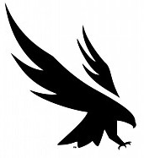

A Letter to My Former Self

Date

Dear Your Name,

Please take this opportunity to write your former self a letter.
If you entered the Hicks Honors College as a freshman, you likely wrote an Honors Colloquium retirement biography. Take a minute to re-read that biography. If you did not write an Honors Colloquium retirement biography, think back to the “first-year in college” version of yourself. All students should consider the following questions: What were your initial goals and dreams? Which of those goals and dreams were realized? Which were deferred? Did any new goals and dreams emerge during your educational journey?
Now, write a letter to your former self. You (a student nearing graduation) should address the letter as if you were writing a letter to be read by the first day of college version of yourself. The letter should address the knowledge and skills that your former self should expect to gain. Talk about unique experiences or opportunities that you participated in, both the expected and unexpected. Address any early fears or concerns and how you overcame those potential limitations. Talk about your proudest moment at UNF. And add a few lines of discussion about the future. Feel free to add anything else you would like to tell your former self.
Signature line,

Your signature

