How to Market Yourself on Linkedin
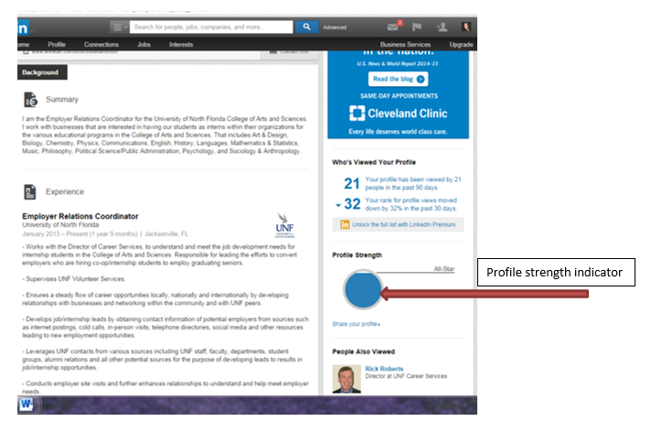
Linkedin is an online networking tool that you can you can use in order to market yourself as a job seeker or to market yourself in your current business/position in order to gain clientele.
After you create your LinkedIn account, the first thing you need to focus on is completing your LinkedIn Profile. The profile completeness gauge on the right hand side of your LinkedIn Profile page shows you how far along in the process you are. In order for your LinkedIn Profile to be 100% complete, your profile needs:
- Current Position
- At least two previous positions
- Education
- Profile summary
- Profile photo
- Specialties
- Recommendations (The more recommendations, the better)

Brand Yourself on Linkedin
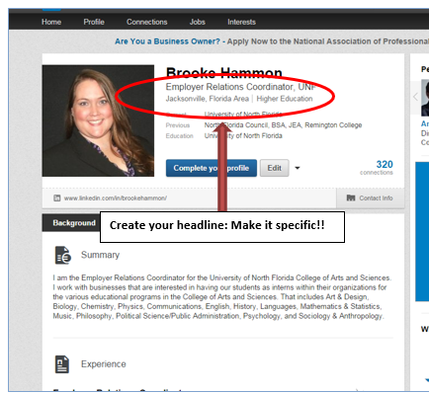

1. Upload Your LinkedIn Profile Photo
Your LinkedIn profile photo is the first thing any visitor's eye will be drawn to. Based on your photo, they will unconsciously and immediately form an impression of you. Above all, your photo should be professional. If you would like to display your personality in your photo, you may do so through your facial expression and pose. Use a photo that shows you are friendly and approachable. Use one that is of only you; a headshot is best, with a neutral background.
Always remember this is not your social networking Facebook page. This is your professional networking page.

2. Create Your Headline
After your photo, the next most important item in your personal LinkedIn brand is your headline. Your headline is what everyone will see next to your photo and your name when you show up in search results or connection suggestions. You want it to be brief, and to tell viewers what you do or what you want to do.
Keep it specific! For example, Pre-PA student interested in Dermatology

3. Fill in Your Summary and Specialties
Your Summary on LinkedIn should be very similar to the summary on your resume. It should be a paragraph highlighting your key capabilities. This is a summary that is to help tell the reader what you are looking for on Linkedin.
Your Specialties should be specific skills that set you apart. This is where you can list certifications and credentials, as well as specific subject matter areas of expertise. Your Specialties must be filled out for your profile to be considered complete.
After completing the sections above, it's time to add all of your work experience.

4. Fill in Your Experience(s)

When adding your work experience to your profile, write position descriptions carefully to showcase your skills and accomplishments. Do not pattern your description after the examples that LinkedIn provides!
Don't just list your responsibilities. When people read your LinkedIn Profile, they don't just want to know what you were responsible for doing - they want to know what you actually did!
Most people that view your LinkedIn Profile may never see your actual resume, so make sure that your LinkedIn Profile is just as good as your resume - if not better. You're not limited to two typed pages, so there's no reason to truncate important accomplishments. At the same time, no one wants to scroll through screen after screen after screen, so make sure you highlight your most important accomplishments for each position.
Once you've completed your work experience, you may choose to further personalize your profile by adding widgets called Applications. One that is definitely useful is the Events application - where you can publish events that you want to share with you connections. Other popular applications include Slideshare Presentations, Blog Links, and Reading Lists. Add whatever ones you think augment your profile, but don't add too many. LinkedIn is not Facebook.

5. Get Connected - Build your network by sending connection requests.

Start building your professional network on LinkedIn by connecting with people you know. LinkedIn gives you the option to use contacts from your online email accounts or from your address books (Outlook, Apple Mail, etc.). Go ahead and send out requests!
As people start accepting your connection requests, you can then look at their contacts to find even more people with whom to connect. Think beyond fellow employees. Connecting with vendors and customers that you have a good relationship with is a great way to expand your network. You should also consider connecting with senior leaders in your own company that you have met in person. These are often great sources for getting introductions to people outside of your normal network.
In order to connect with someone on LinkedIn, you need to establish one of the following relationships:
- Colleague - you worked together in a previous position listed in your work experience
- Classmate - you went to school together at a school listed in your education
- We've done business together - you've done business while in a previous position listed in your work experience
- Friend - you need to know the person's email address to establish the connection
- Groups & Associations - you are members of the same LinkedIn Group (see next section)
When you send a LinkedIn invitation, LinkedIn will send a connection request to the person specifying in what capacity you know them. The person will then either accept or reject the connection request.

6. Ask for Recommendations
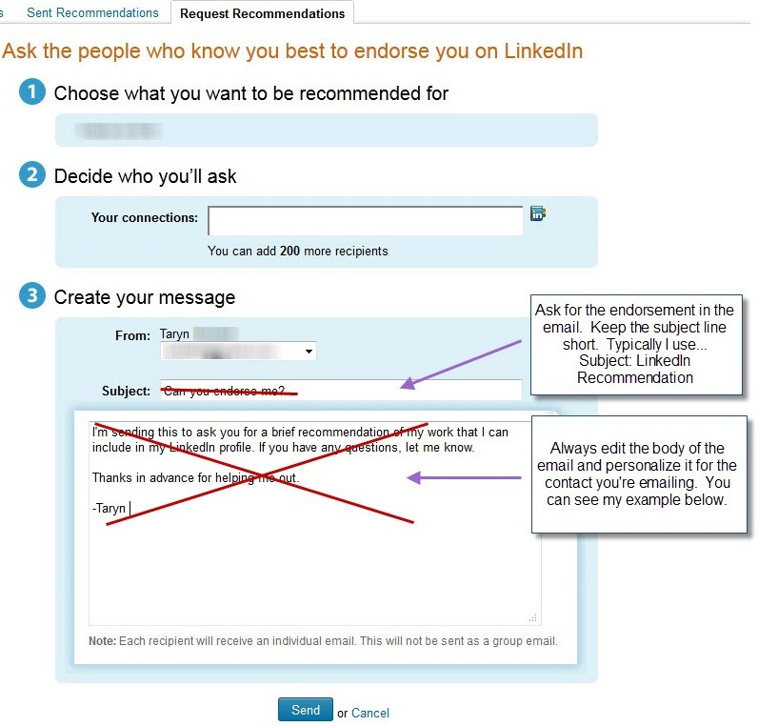
This is the last step to completing your profile. You don't need to get recommendations from everyone you know. First, target the positions that you want recommendations for as LinkedIn Recommendations are specific to your work experience entries. Make sure you get recommendations across the entire span of your work experience - you definitely need recent recommendations, but you should also get recommendations going all the way back to the beginning of your work experience. This can help to show that you have performed consistently throughout your career. Ask for one or two recommendations for your most recent position, one or two for a position in the middle of your work experience, and one or two from the beginning of your work experience. You need three to complete your profile, and probably don't need any more than seven.

7. Join Groups

Get the most out of your Linkedin experience by joining groups. Groups are a fantastic way to expand your network. LinkedIn has over 375,000 groups - and that number is growing every day! So how do you find the right ones? Here are tips for finding relevant groups that will help you find meaningful connections.

1. Join Alumni Groups
From the Groups page, click the Find a Group button and enter your Alma Mater in the search box. Most Universities and colleges have alumni groups that you can choose to join. They may also have special interest or organizational (fraternities, clubs, etc) groups that you can join as well. This is a great way to leverage your alumni status to ask others for introductions to their connections. Most alumni will be happy to help out!
Military service counts too! If you have prior military service, join the groups for your branch of service, as well as for any units that you served with.

2. Join Professional Association Groups
Most professional associations have at least one LinkedIn group. Many have separate groups for their major chapters as well. Go ahead and join the groups for any associations that you are affiliated with.
3. Join Many Company Groups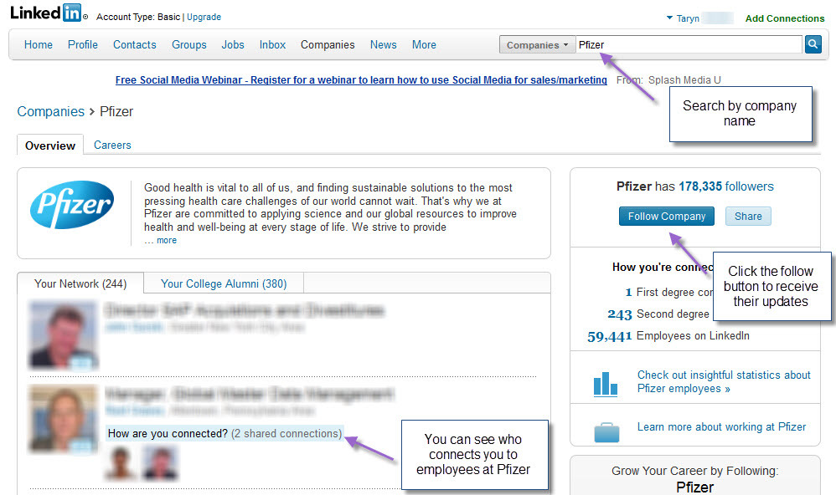

More and more companies are creating their own LinkedIn groups. Go ahead and join! If you want, you can also join the groups of customer or supplier companies. If you are a job seeker, join the groups of any companies that you are targeting.
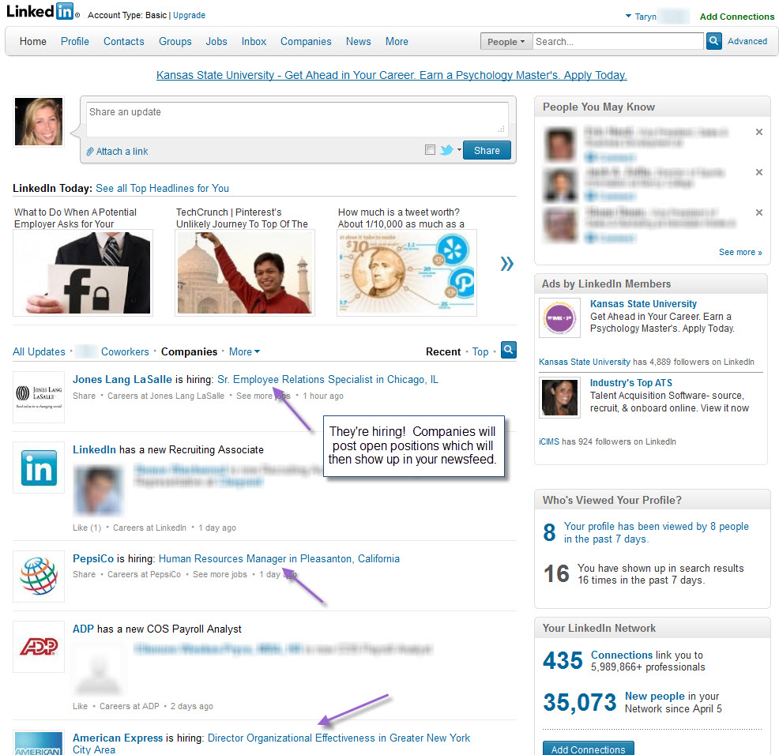

4. Join Groups that Relate to Your Profession
If you're a consultant, join some consulting groups. If you're a manager, join management groups. Find and join any groups that are related to your profession or field of interest.

5. Look at Your Connections for Group Ideas
See what groups your LinkedIn Connections belong to. If any of them are interesting and relevant, go ahead and join! Your connections are a great way to find out about groups.

6. Create Your Own Group
If you can't find a group you're looking for, go ahead and create one! Once you create the group, send invitations to all of your contacts who might be interested, and then start posting some discussions to build momentum and attract others to the group.

Reference: Adapted from “LinkedIn How To”, www.squidoo.com. 2013
Other Resources:
https://university.linkedin.com/linkedin-for-students
https://www.reputationmanagement.com/blog/reputation-management-for-college-grads/

